**U-Land**

**Testing Document**

(Arsalan Syed)

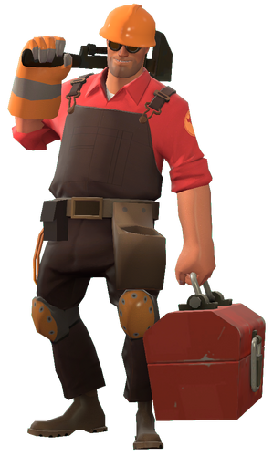

Table of Contents

Playtesting 1 4

Testing Plan 4

Overview 4

Plan 4

Testing Results 7

Changelog 1 15

Level Iterations 15

Overview 15

Iteration #1 - Shrinking point & Extra space 15

Iteration #2 – Resizing & Adjusting the Tower position. 18

Iteration #3 – Removing Stairs to the tower from spawn. 20

Iteration #4 – Adding Another exit. 21

Iteration #5 – Adjusting Spawn Room size and position. 22

Iteration #6 – Adding Levitation to Blue Room 24

Iteration #7 – Adding cover for Blue Flank area. 27

Iteration #8 – Adjusting Pickup Position 28

Iteration #9 – Adding Blockage to the edge of Mini-Tower 29

Iteration #10 – Adjusting Point Cover 30

Iteration #11 – Blue Room Adjustment 31

Iteration #12 – Removed the Main Entrance Door 32

Iteration #13 – Making Red Room Smaller 33

Iteration #14 – Filling Empty Spaces 34

Iteration #15 – Changing the Full Health kit to Medium. 35

Iteration #16 – Added Direction Signs. 36

Erroneous data 37

Data # 1 37

Zoning Table 1 38

Keys – Areas Characters would use the most. 38

Playtesting 2 41

Testing Plan 41

Overview 41

Plan 41

Testing Results 45

Changelog 2 50

Level Iterations 50

Overview 50

Iteration #1 –Pickups Position Adjusted 50

Iteration #2 – Sentry Position Added 52

Iteration #3 – Side Exit Cover Change 54

Erroneous data 55

Data # 1 55

Data # 2 55

Data # 3 56

Data # 4 57

Zoning Table 2 58

Keys – Areas Characters would use the most. 58

Comparing Playtests Result 61

Were my Iterations a success? 61

Example #1 61

Example #2 62

Example #3 62

Overall Changes (Gif) 63

# Playtesting 1

## Testing Plan

### Overview

Plan is to create a survey using Microsoft Forms and use it to gather feedback regarding my map. The questions will be more general as I want players to give their opinion about each part of the map and how they felt about it. This will help me improve those section of the maps and then later focus more on specific things in each part of the map.

### Plan

I wanted to know who played, what to understand from what character perspective am I receiving my feedback from. This will help me understand and do my own playtesting to see if the changes I will make will have the impact on the right character.

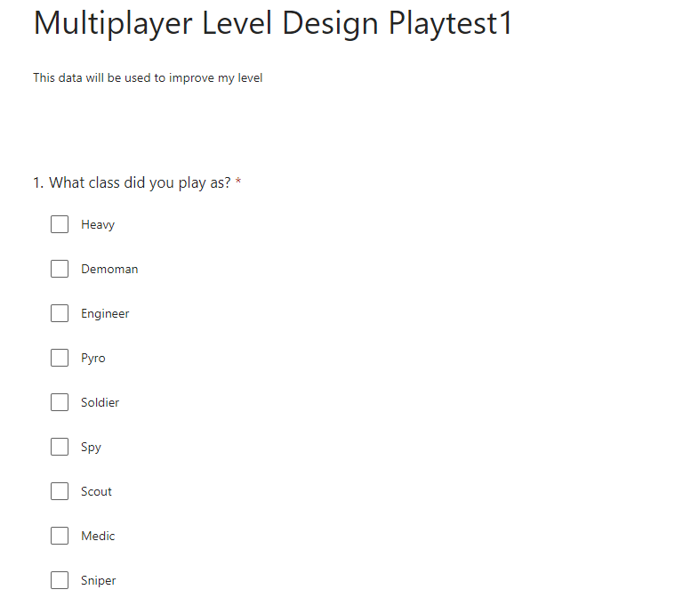

For all the key areas of the map, I asked questions such as rating for that specific area and why that rating was given. This was to see if players liked that area or not and why, to help me understand how I can improve that part of the map.

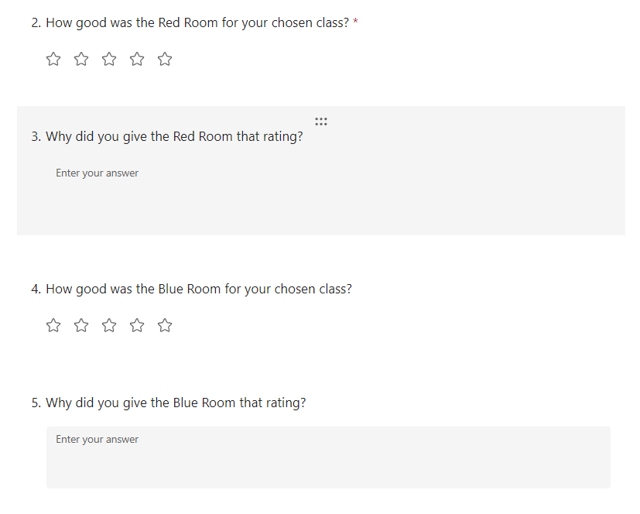

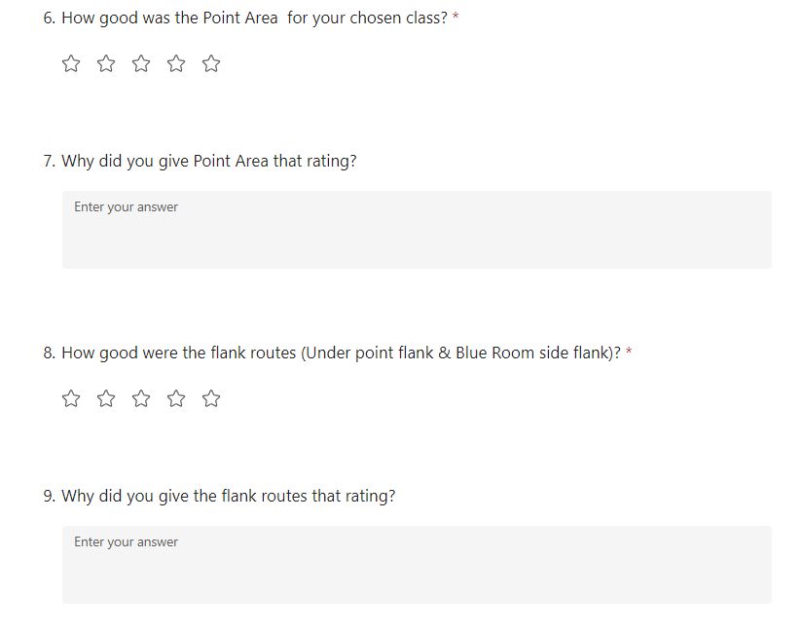

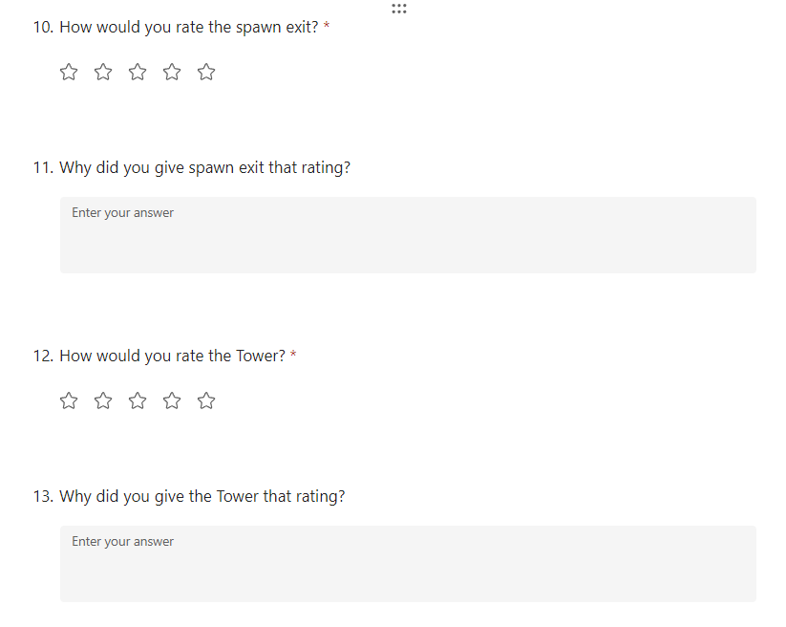

I then asked more general questions to get overview of the map regarding bugs, balance issue and overal imrpovement that can be made.

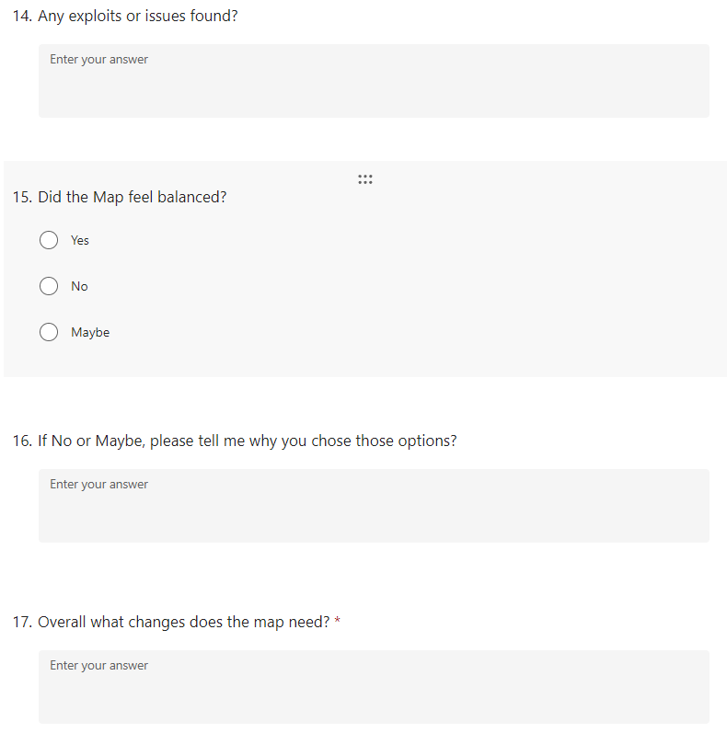

## Testing Results

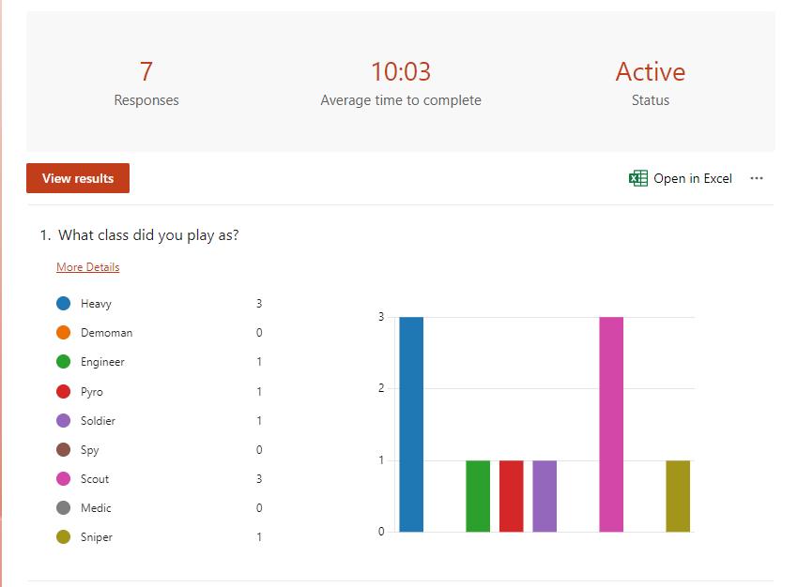

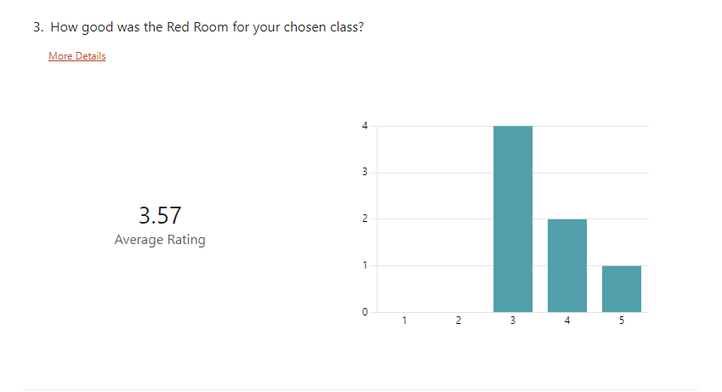

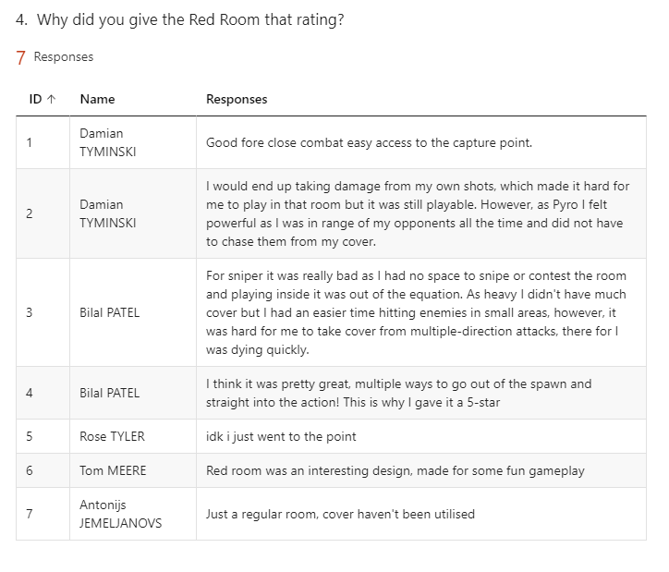

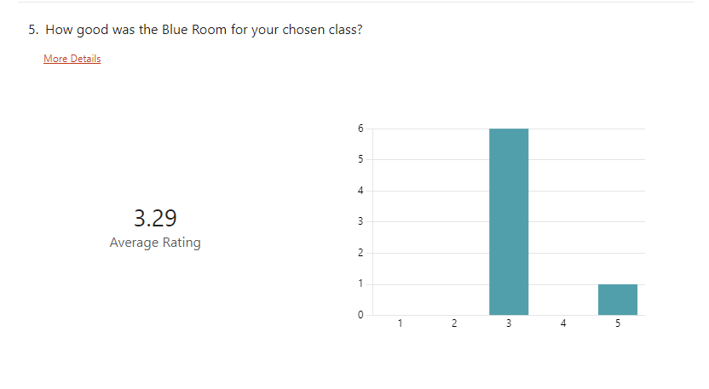

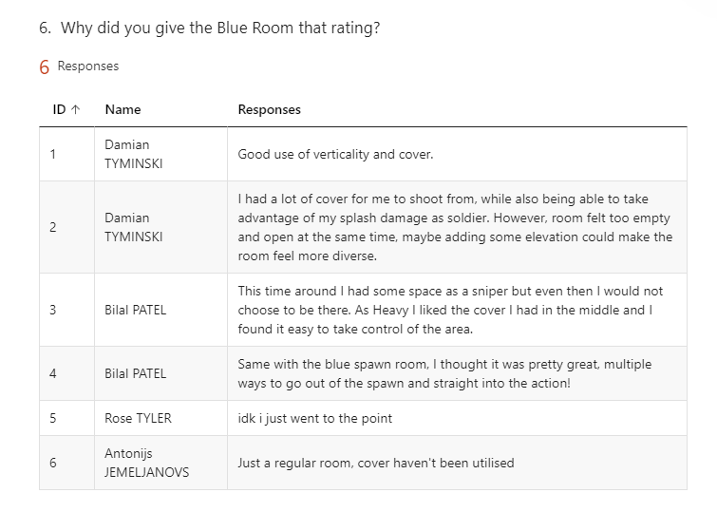

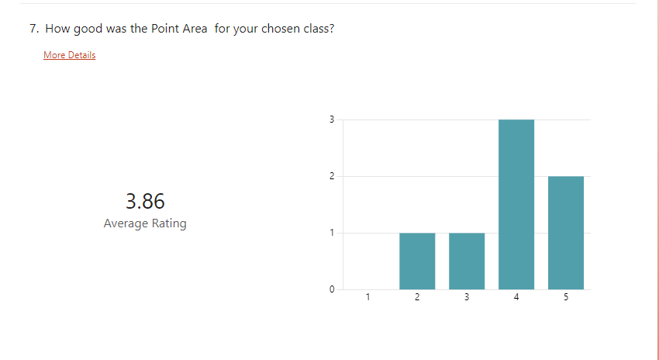

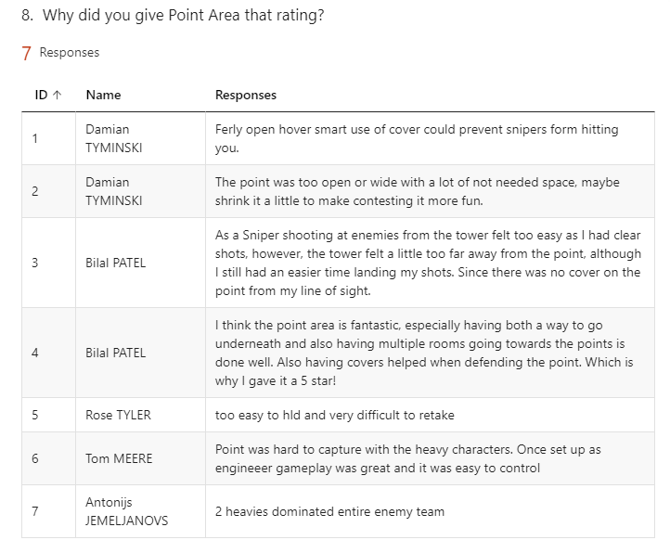

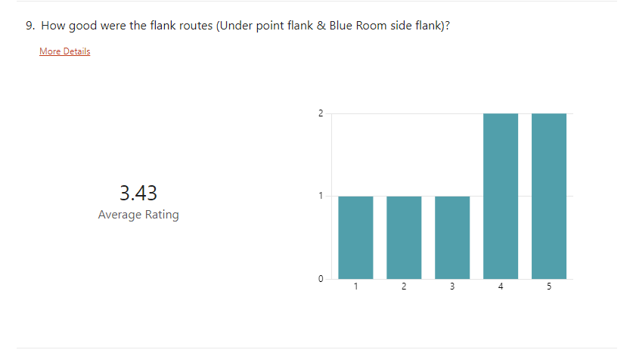

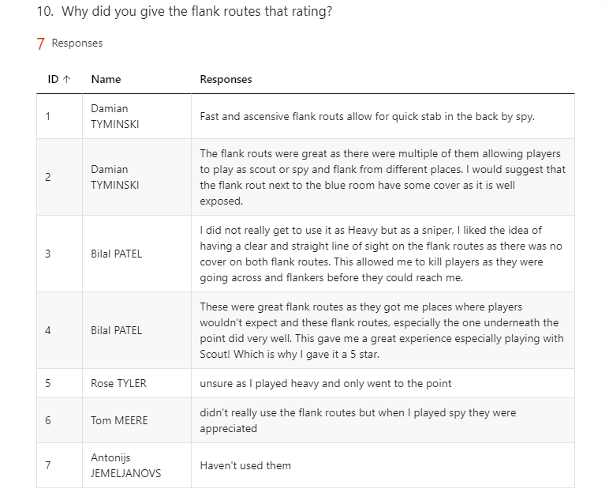

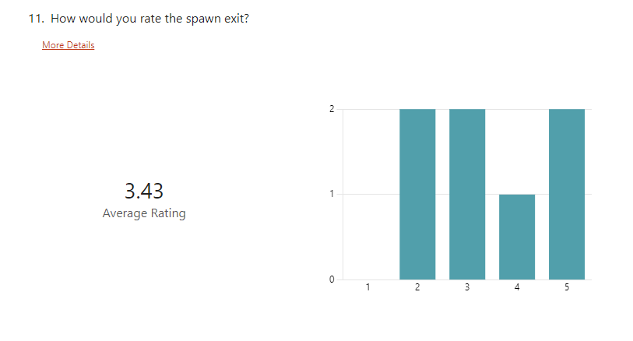

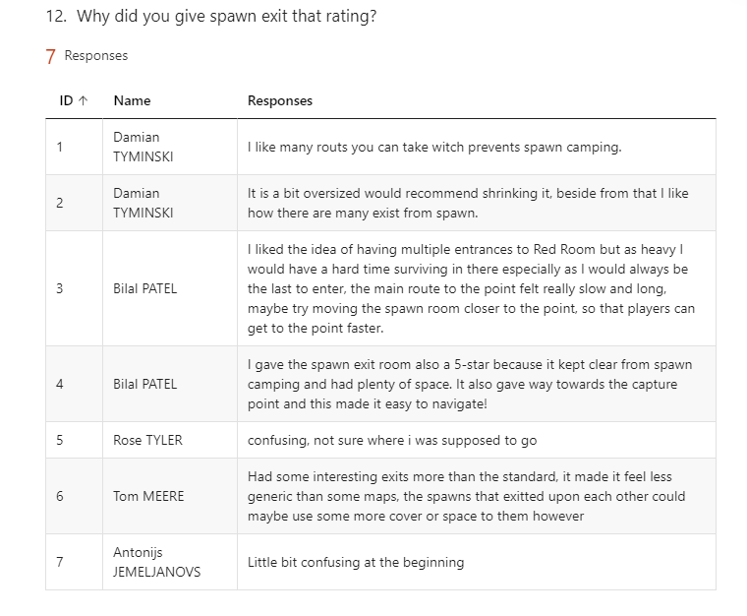

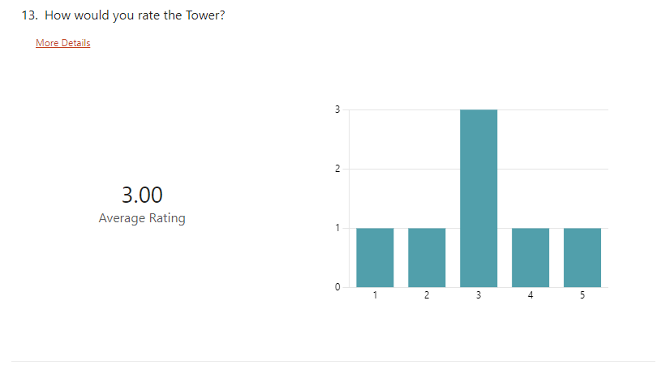

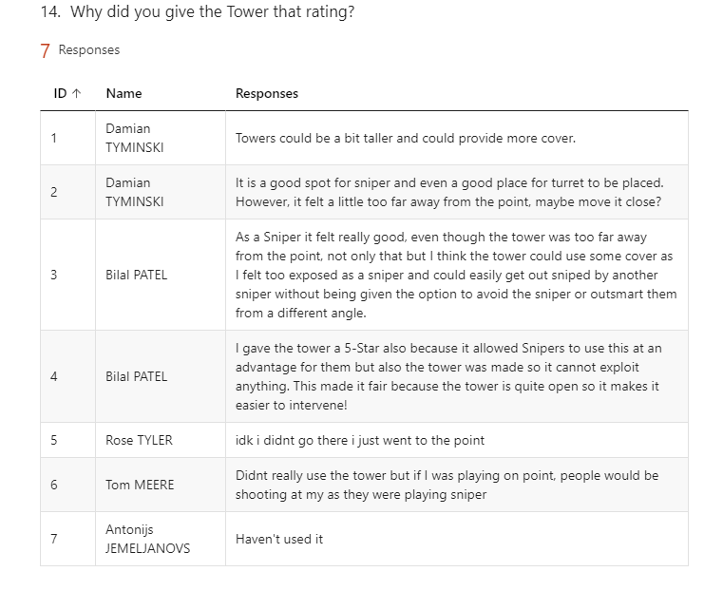

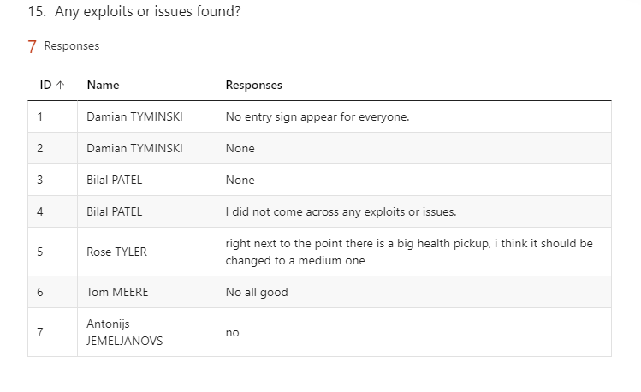

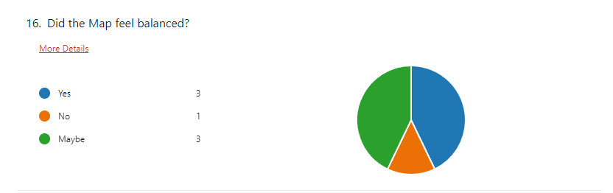

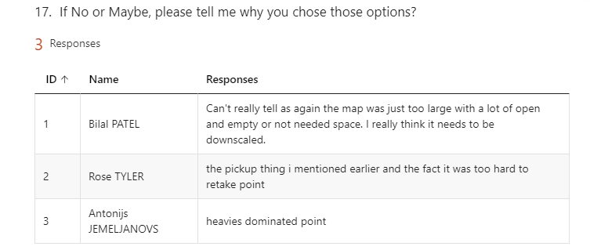

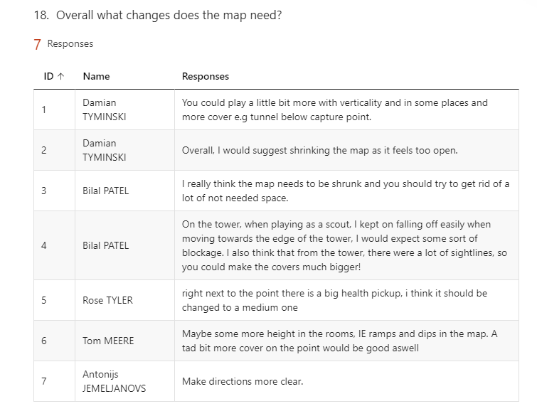

# Changelog 1

## Level Iterations

### Overview

On my first mini-playtesting, I received responses regarding how my map had a lot of empty spaces and how it needed to be downscaled. Having a large map also made the game feel slow and this was bad considering TF2 is all about chaotic and constant fighting.

### Iteration #1 - Shrinking point & Extra space

#### [ Characters played ]





#### [ Feedback given ]

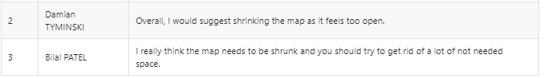

#### [ Feedback Overview ]

The response suggests that the map did not meet the standard size of TF2 maps, as the map is too large, with a lot of empty spaces that will not be used.

#### [ Feedback Consideration ]

I decided to shrink the map, starting with the point area as that is the center area. This resulted in moving the Blue room closer to the spawn allowing players quick access to Blue Room, it also shrunk the point and I tried to use my research on TF2 maps to take into consideration how big the point area should be, when shrinking it.

**[ Original ] [ Change ] Point Shrink**

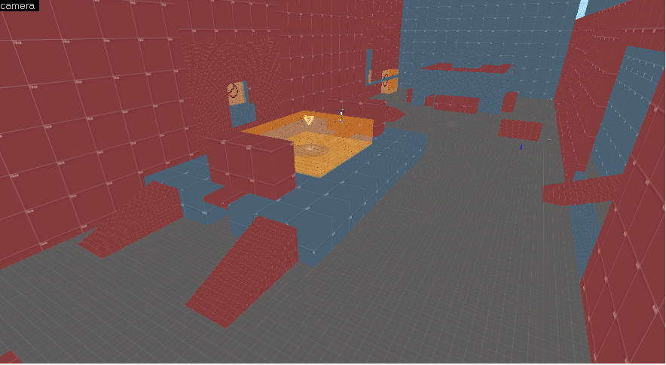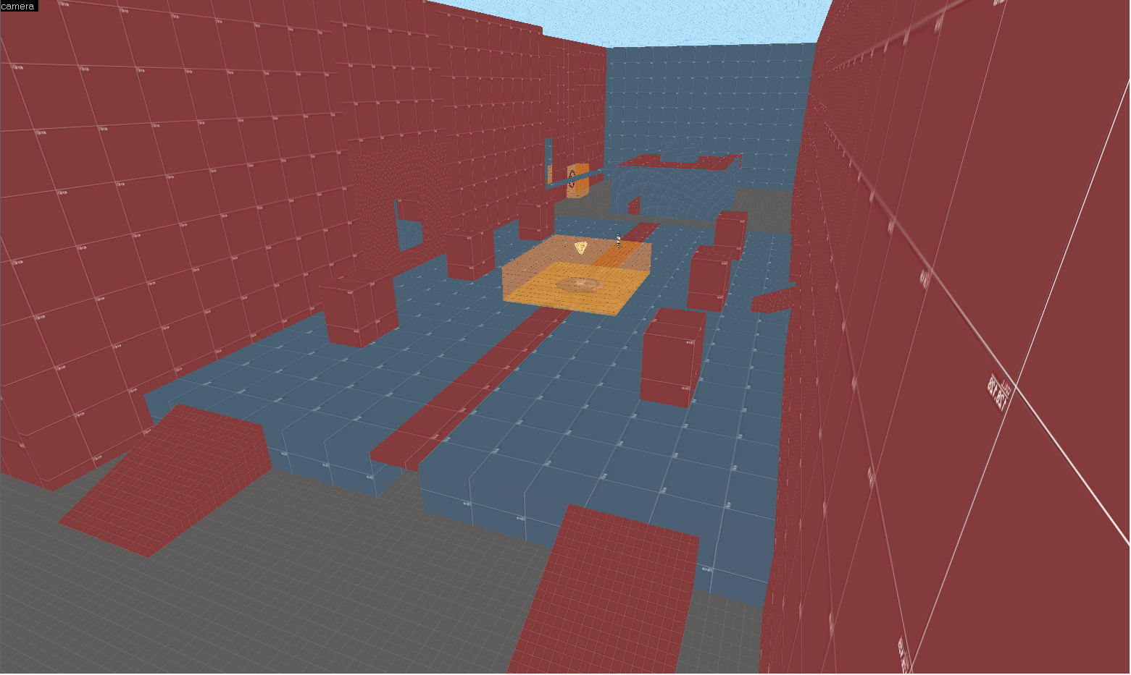

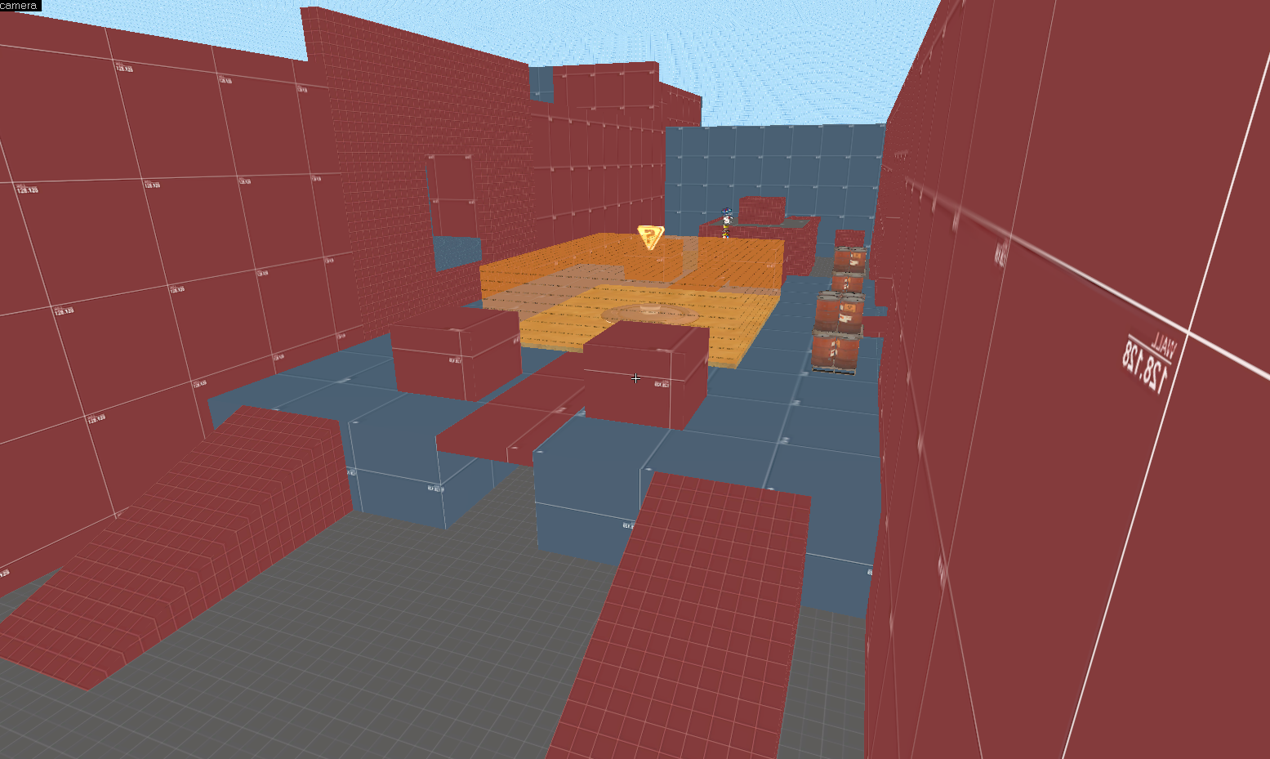

**[ Original ] [ Change ]**

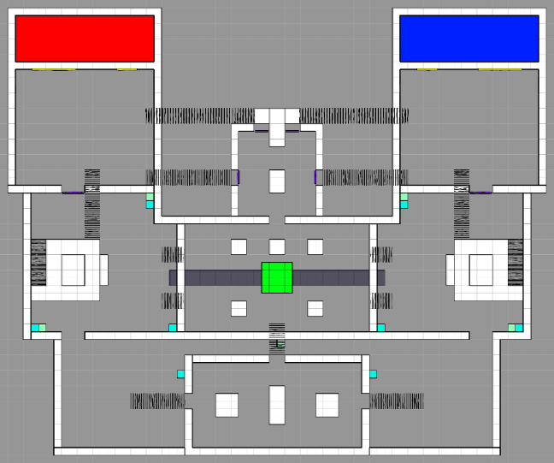

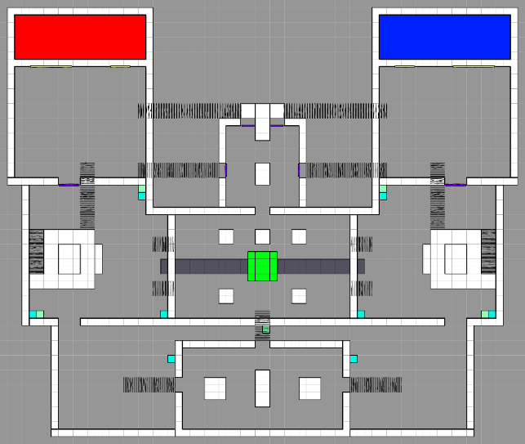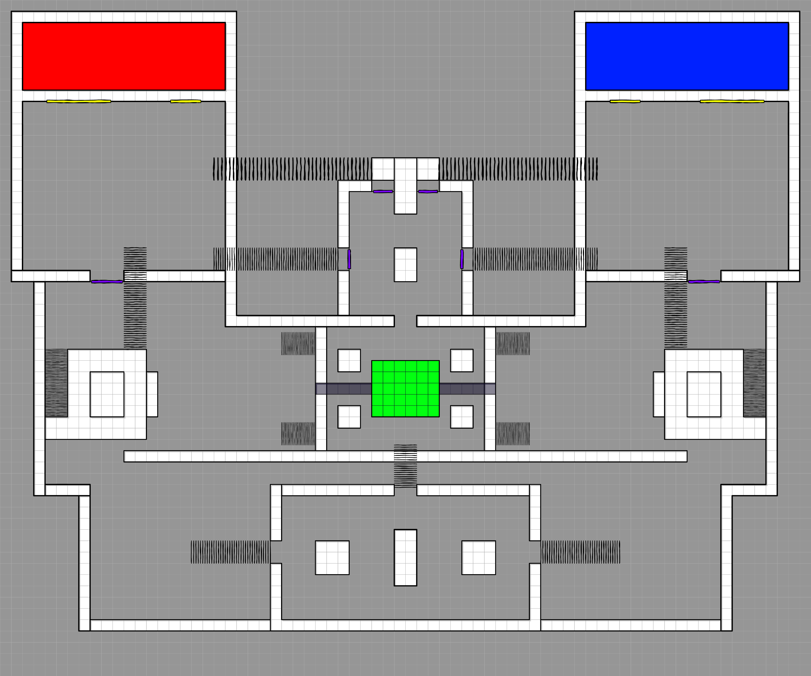

**[ Feedback Consideration ]** The feedback also suggested that there were a lot of empty spaces that were not being used, so I decided to get rid of that extra space by moving the walls closer to the Blue Room.

**[ Original ] [ Change ]**

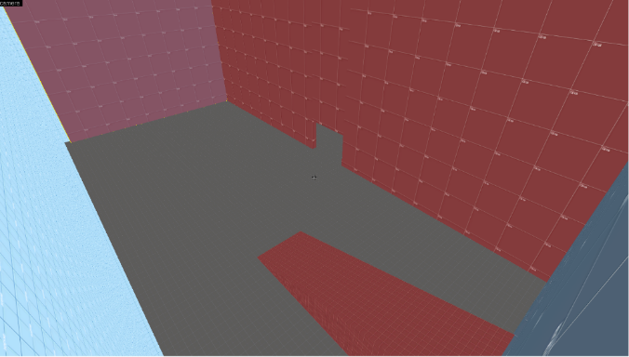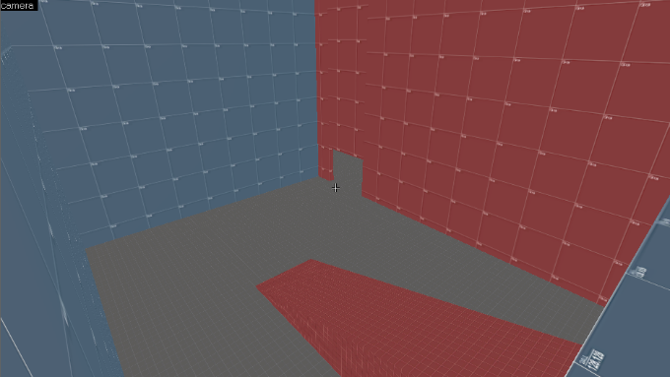

**[ Original ] [ Change ]**

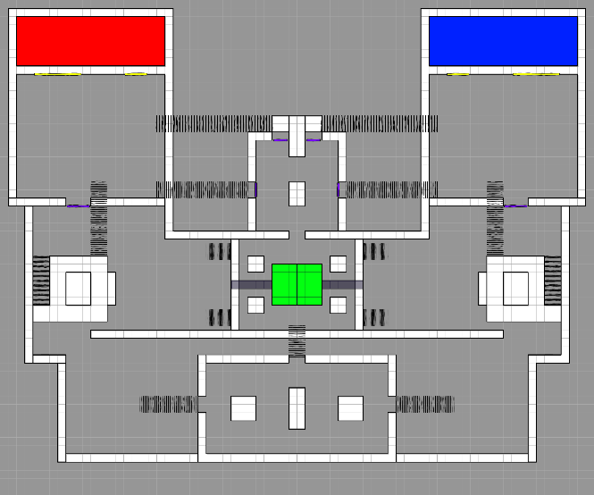

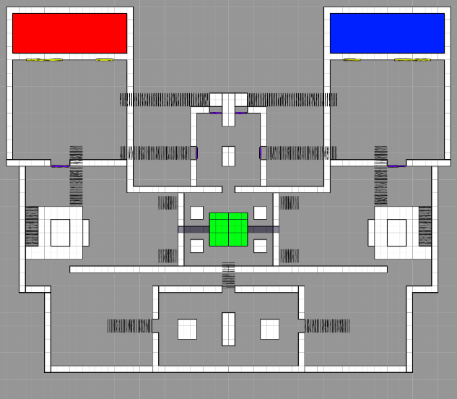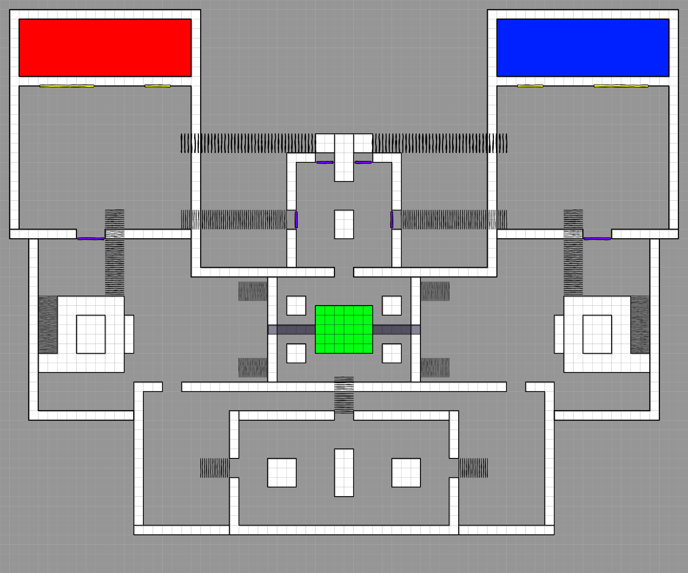

### Iteration #2 – Resizing & Adjusting the Tower position.

#### [ Characters played ]



#### [ Feedback given ]

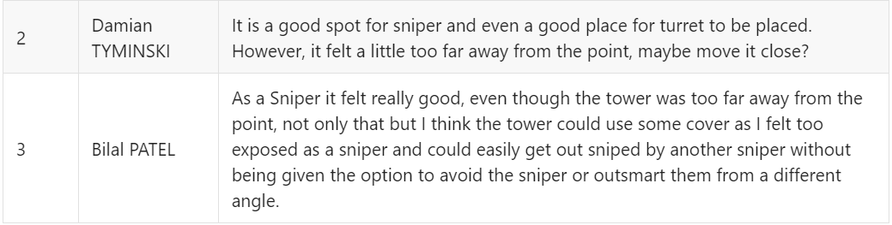

#### [ Feedback Overview ]

The feedback suggests that the tower is a nice safe spot for the sniper, which is how I intended for the tower to be, however, it seems like the spot is too good for the sniper. One of the reasons is that the tower is far away from the point making it hard to spam it and takes flankers longer to reach the sniper.

The feedback also gave hint for it being good place to put a sentry, however, I can see that due to tower being far away from the point, the sentry will not provide as much value as it should.

#### [ Feedback Consideration ]

I decided to move the Tower closer and make its size half the size of what it originally was. It is now called a Mini-Tower. This will result in Sniper not feeling too safe, as opposing team flankers can get to the Mini-Tower faster as well as enemy team can spam the Mini-Tower.

To balance things out, I also added some cover for the sniper, however this would not be enough as characters like soldier can apply splash damage to the sniper, which is why I allowed the center cover on top of the tower to remain, as Sniper can re-position behind it, which will reduce the line of sights, but it will provide more safer positioning. This will provide sniper with some flexibility.

Additionally, engineers can also place their turret on the tower as it can attack players on the point, making their turret more useful now.

Finally, the platform in front of the tower has been removed, originally it was there to allow the player to jump down without taking damage, however now that I have shrunk the Tower, it is no longer needed.

**[ Original ] [ Change ]**

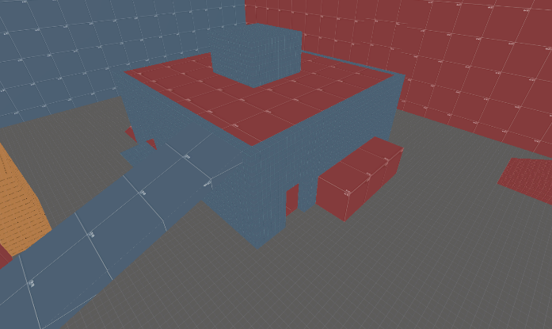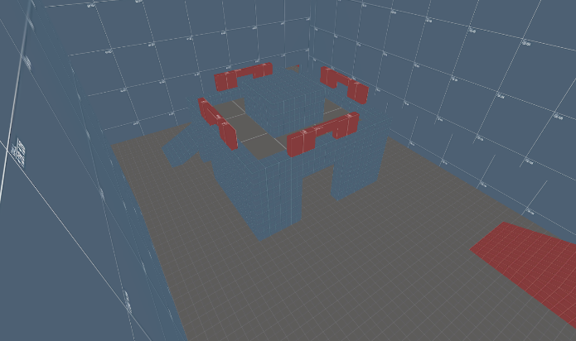

**[ Changes ] :**

* Moved closer.
* Provided cover.
* Shrunk the Size of the tower.
* The platform in front of the tower was removed.

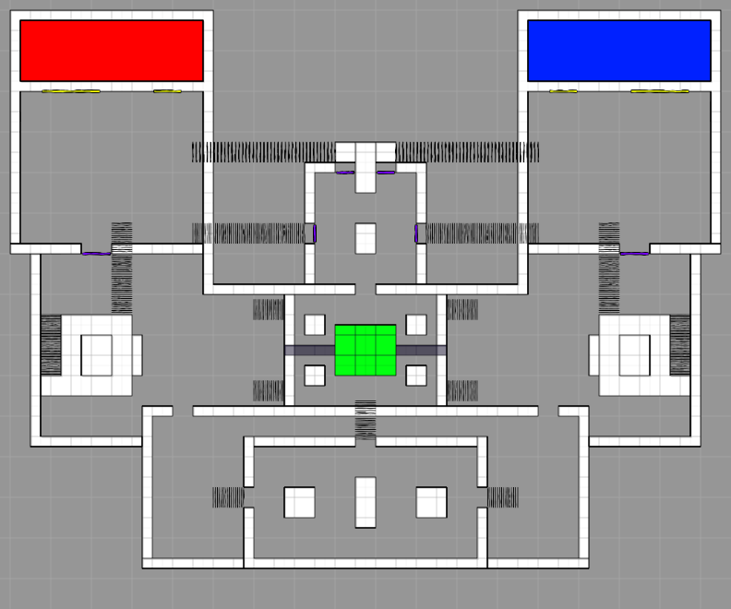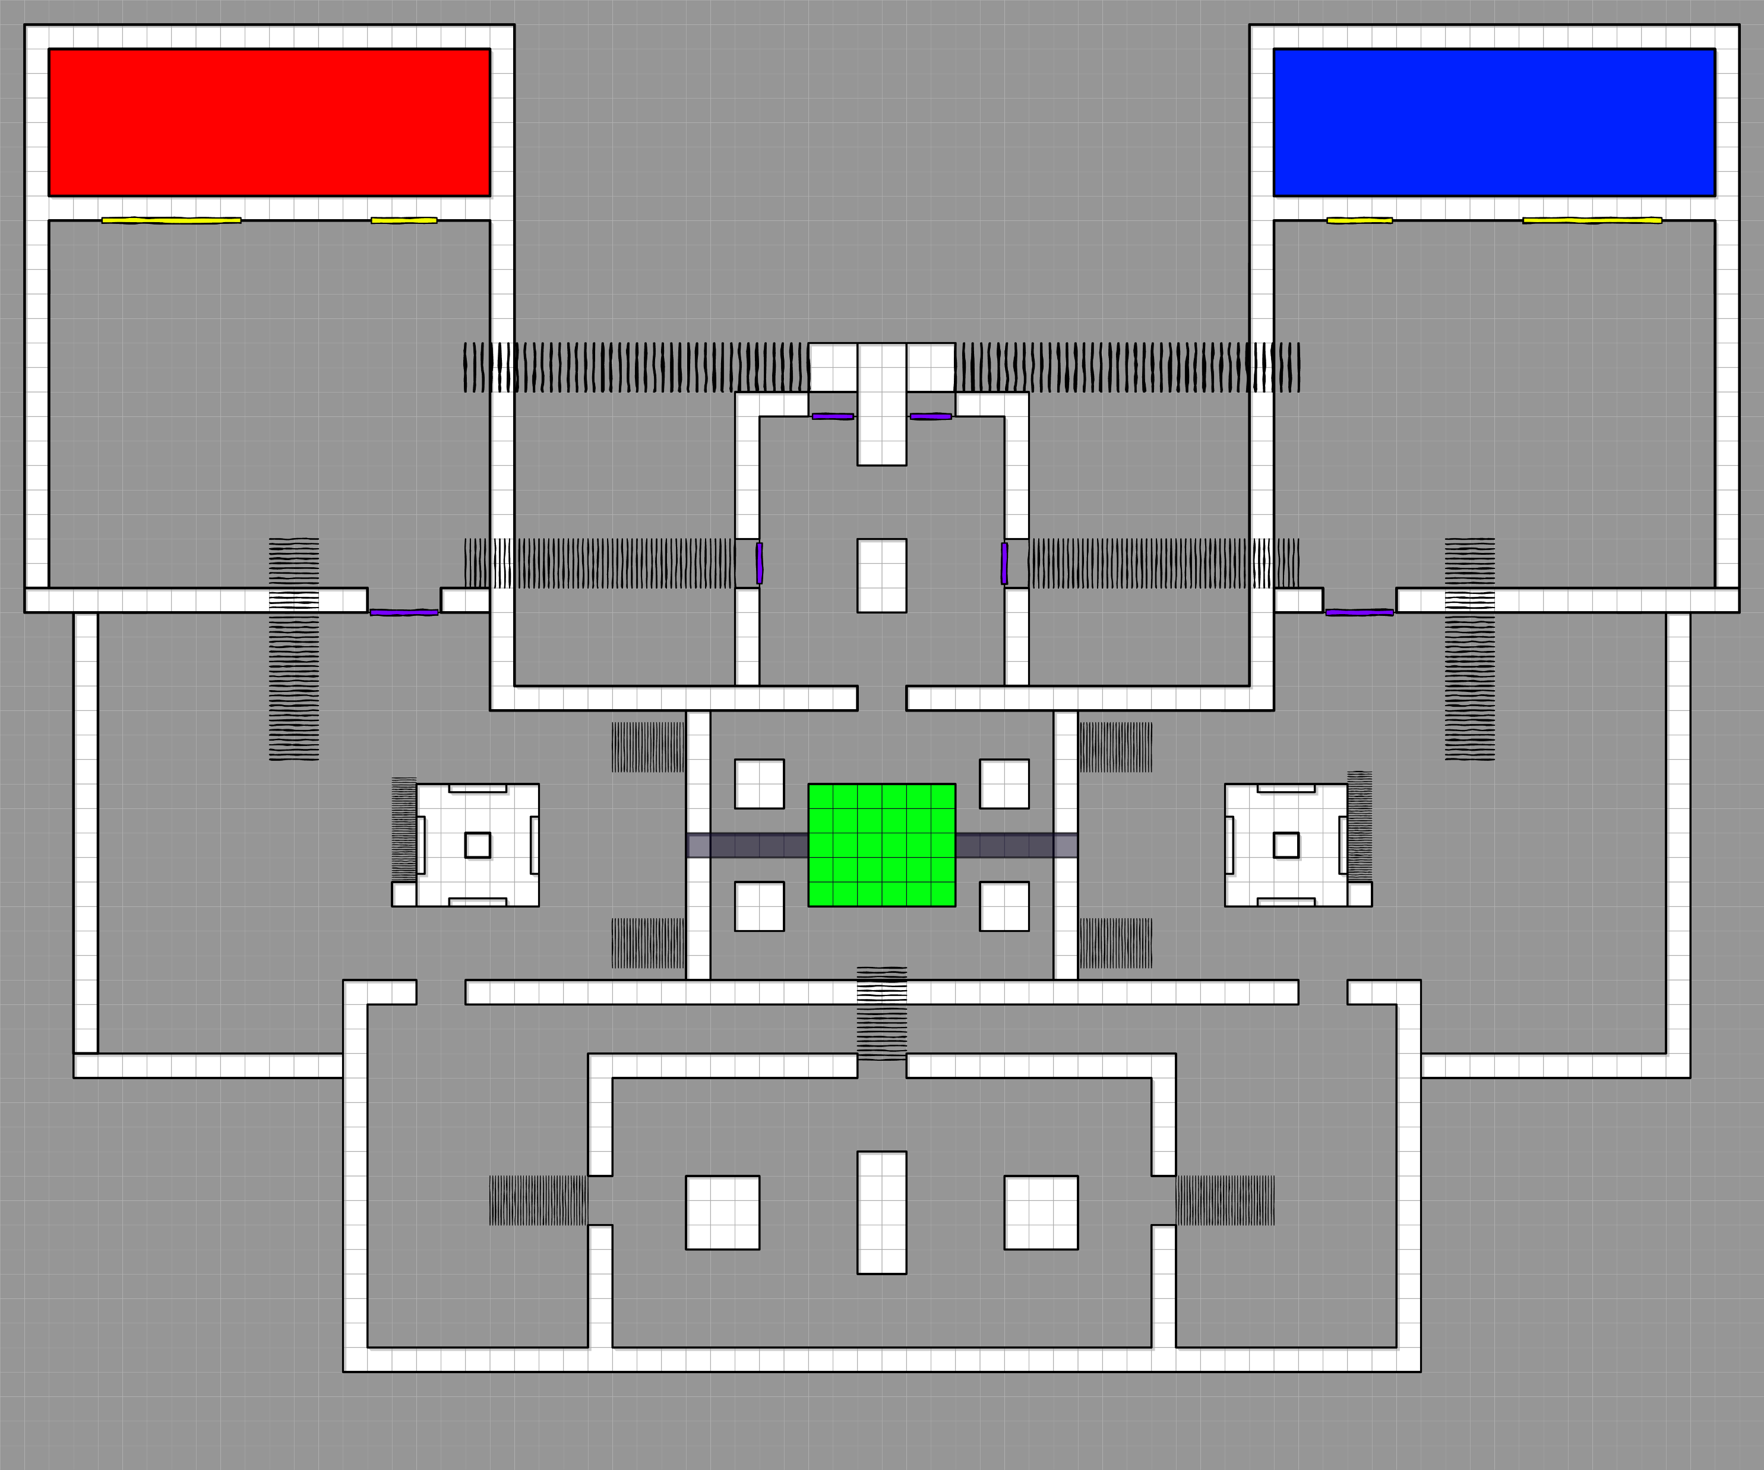

### Iteration #3 – Removing Stairs to the tower from spawn.

#### [ My Consideration ]

Moving the tower closer and removing the extra space at the back resulted in my original design structure not fitting well, so I had to remove the stairs that took the player straight to the top of the tower. This change was needed as keeping the stairs could have made the area feel more cramped.

**[ Original ] [ Changes]**

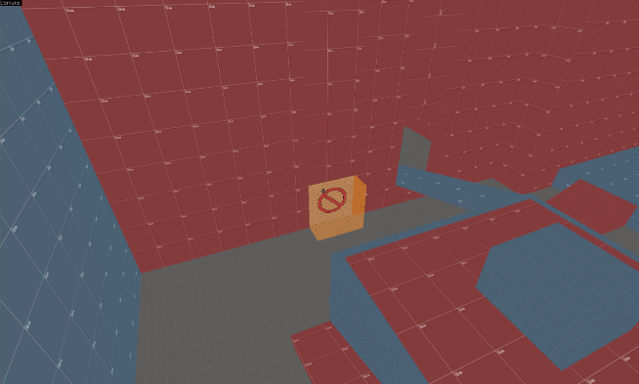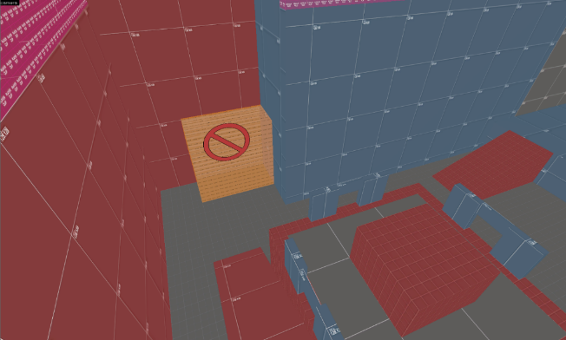

**[ Changed ] :**

* Moved the side wall closer.
* Stairs to the top of the tower are removed.
* The Exit Door moved closer to the tower.

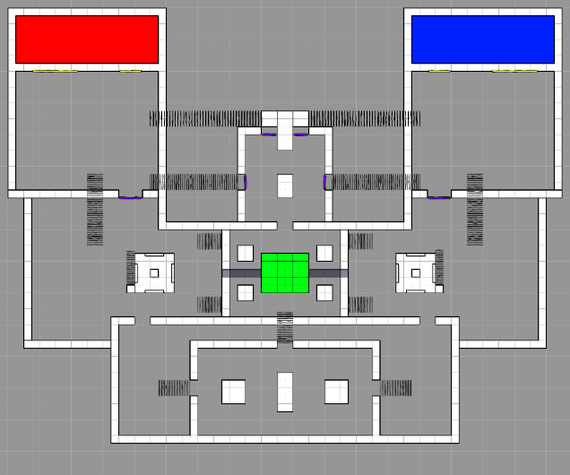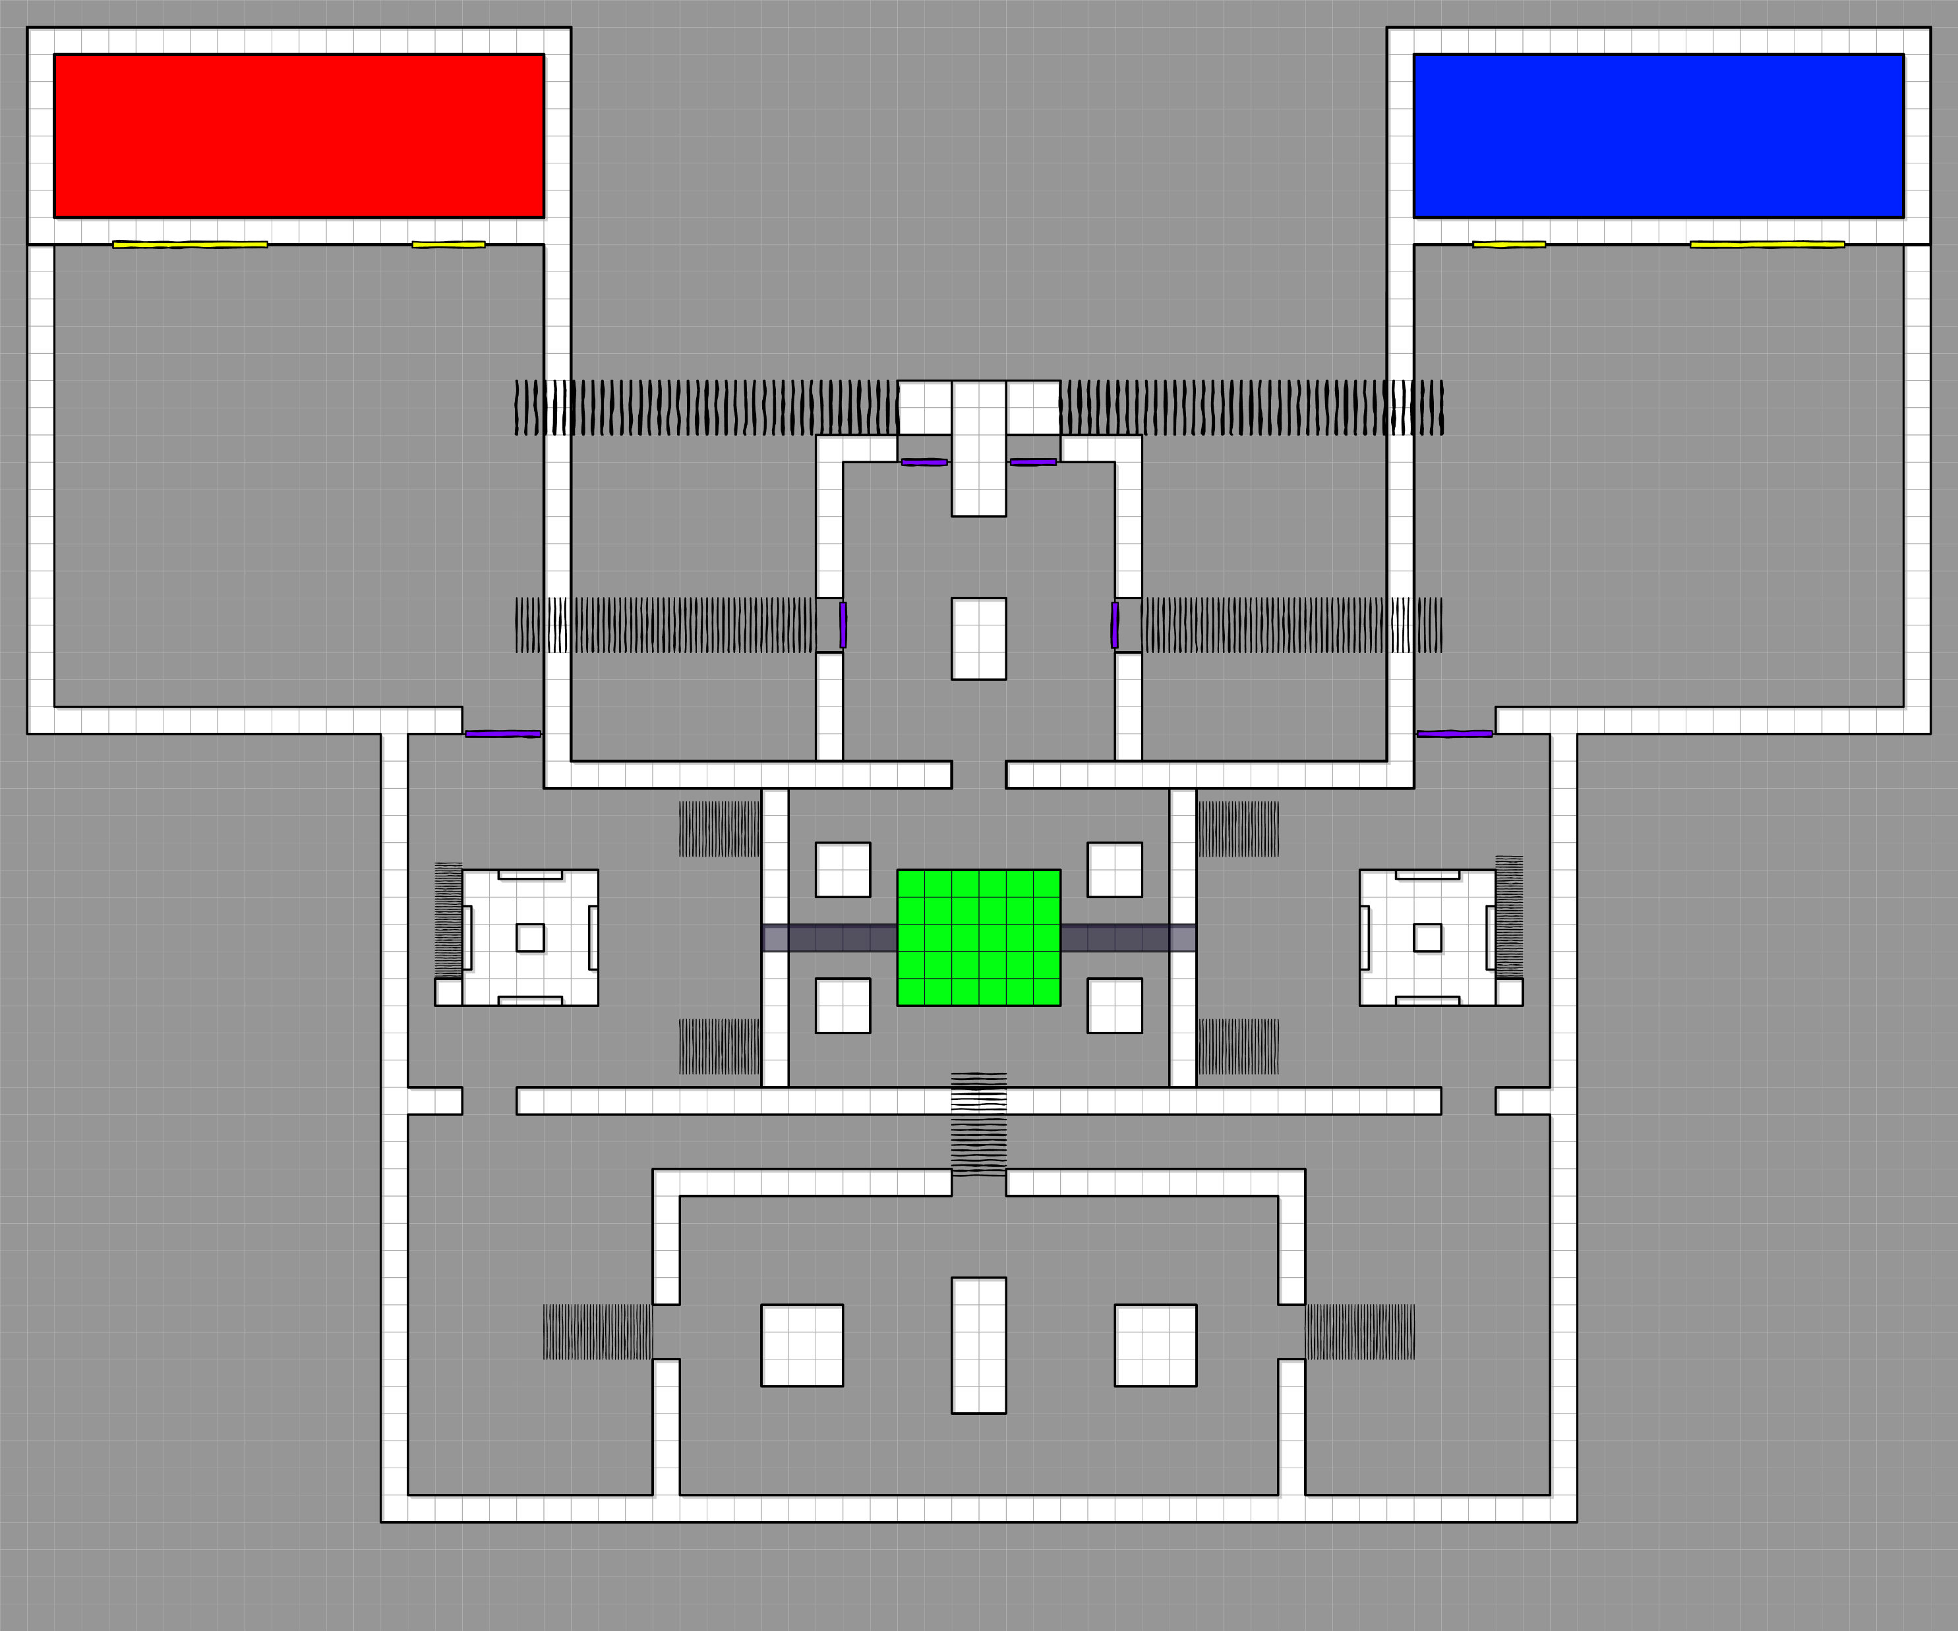

### Iteration #4 – Adding Another exit.

#### [ My Consideration ]

After removing the stairs, I decided to create a clear and safer path towards the Blue Room. This is to make sure that players that are trying to get to the other side don’t get spammed at by the opposing team when crossing across to get to Blue Room. It also prevents spawn camping and players finding it hard to get out of that cramped area.

**[ Original ] [ Change ]**

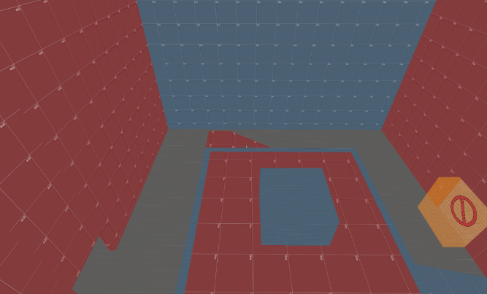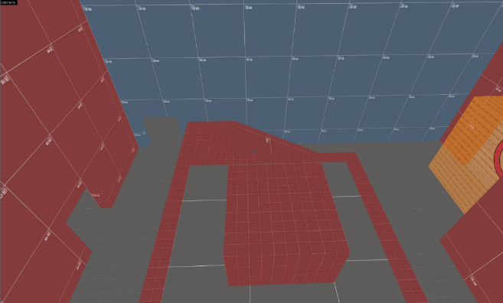

#### [ Additional Change ]

This was added to prevent a clear long line of sight towards the spawn, although likely hood of Sniper peaking from there is very slim, I still think it is a good idea to just eliminate that opportunity, even for other characters like Soldier.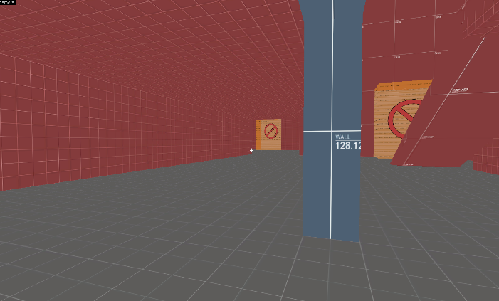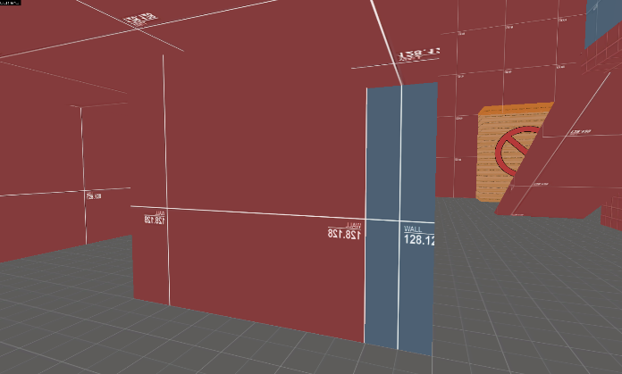

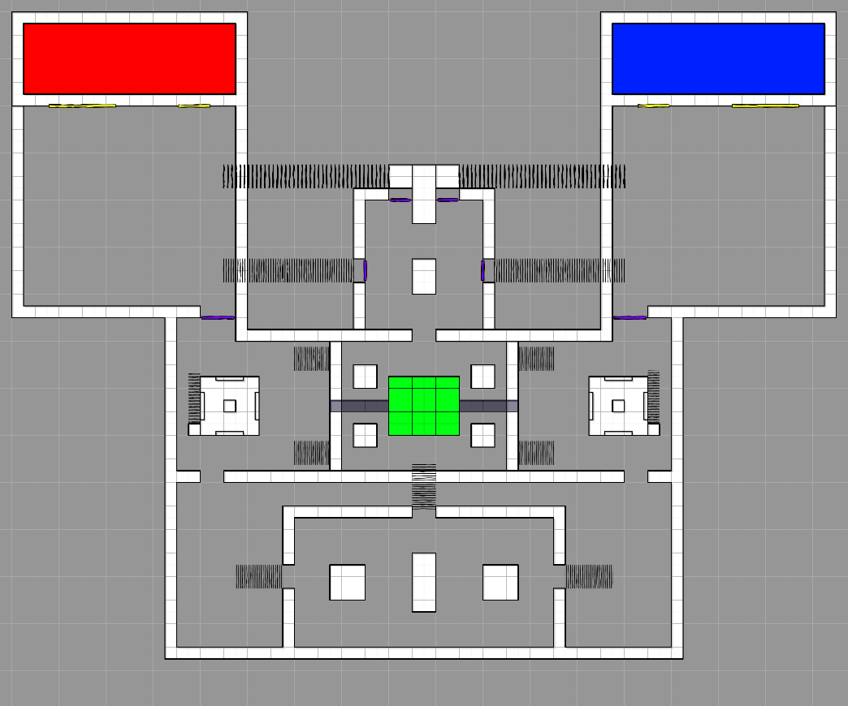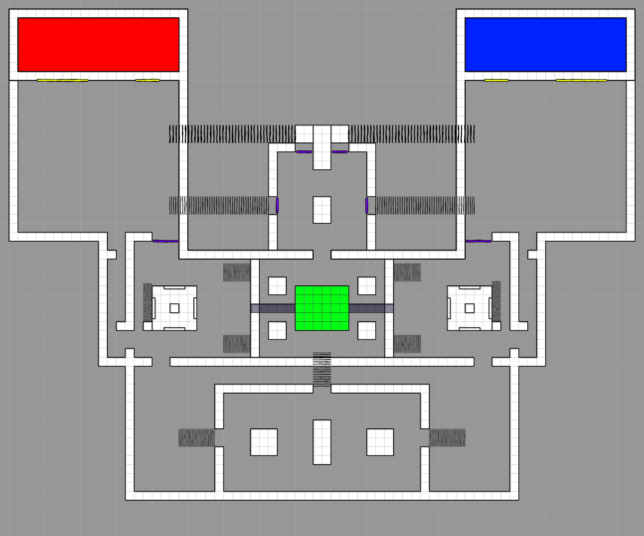

### Iteration #5 – Adjusting Spawn Room size and position.

#### [ Characters played ]





#### [ Feedback given ]

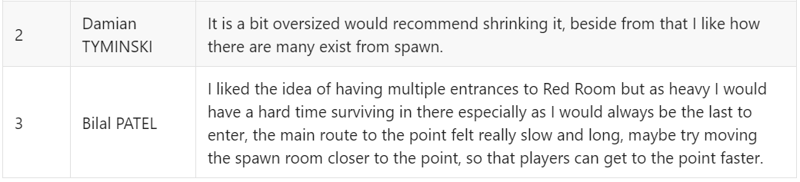

#### [ Feedback Overview ]

For the spawn I think the size is not the issue as much as the fact that there is a lot of empty space as you get out of the spawn which makes the spawn room itself feel big. It also seems like the time it takes to get to the point is a lot longer than I would like it to be.

#### [ Feedback Consideration ]

One of the things that I did not take into consideration was the time that it takes to travel to the point. I did some play testing on the official TF2 map and found out that on average it takes about 15 – 18 seconds for heavy to reach the point, with that in mind I moved the spawn room closer and now on average it takes about 12 - 15 seconds for heavy to reach the point. I made it a little faster because I wanted my map to feel chaotic and more engaging.

**[ Original ]**

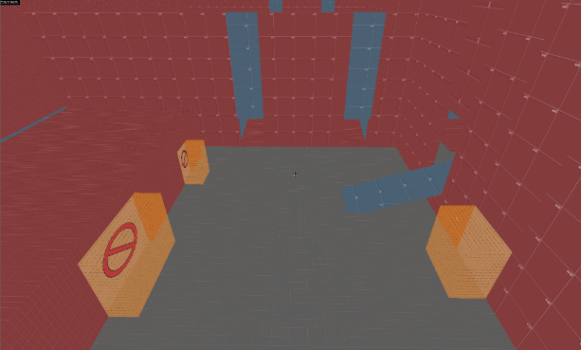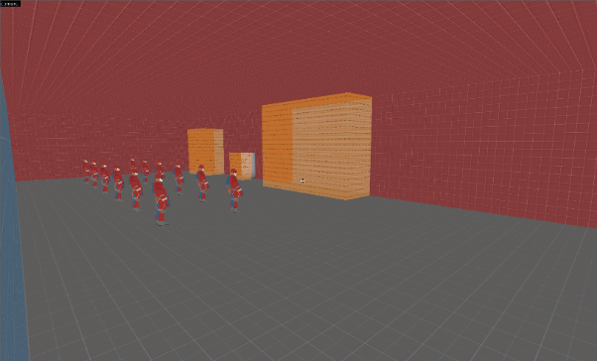

**2**

**1**

**[ Change ]**

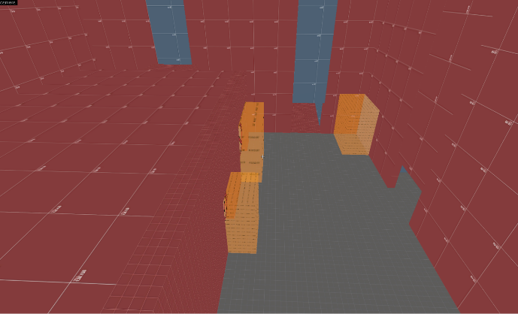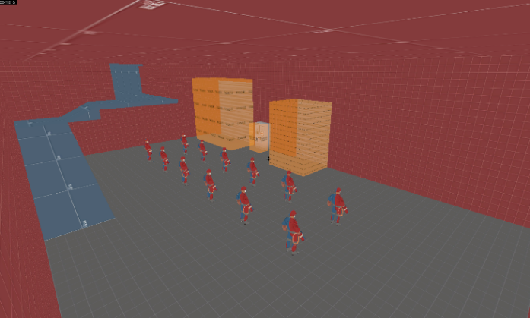 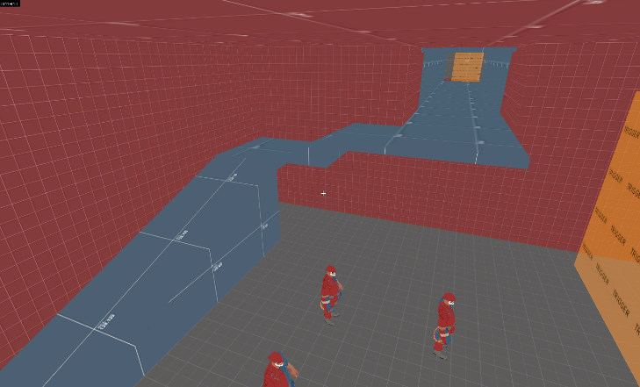

**2**

**1**

**[ Changes ] :**

* Moved the spawn closer.
* Moved Exit one within the spawn room.

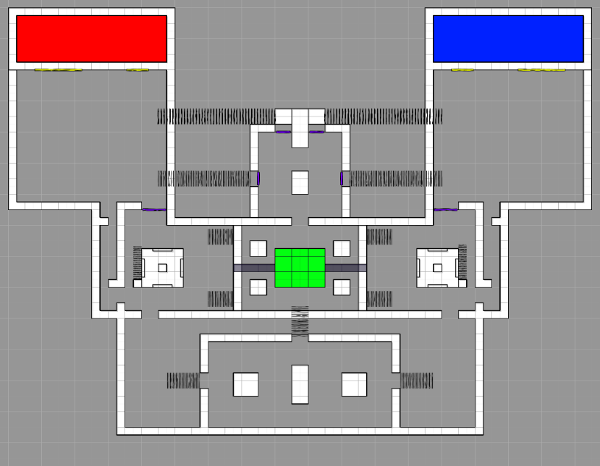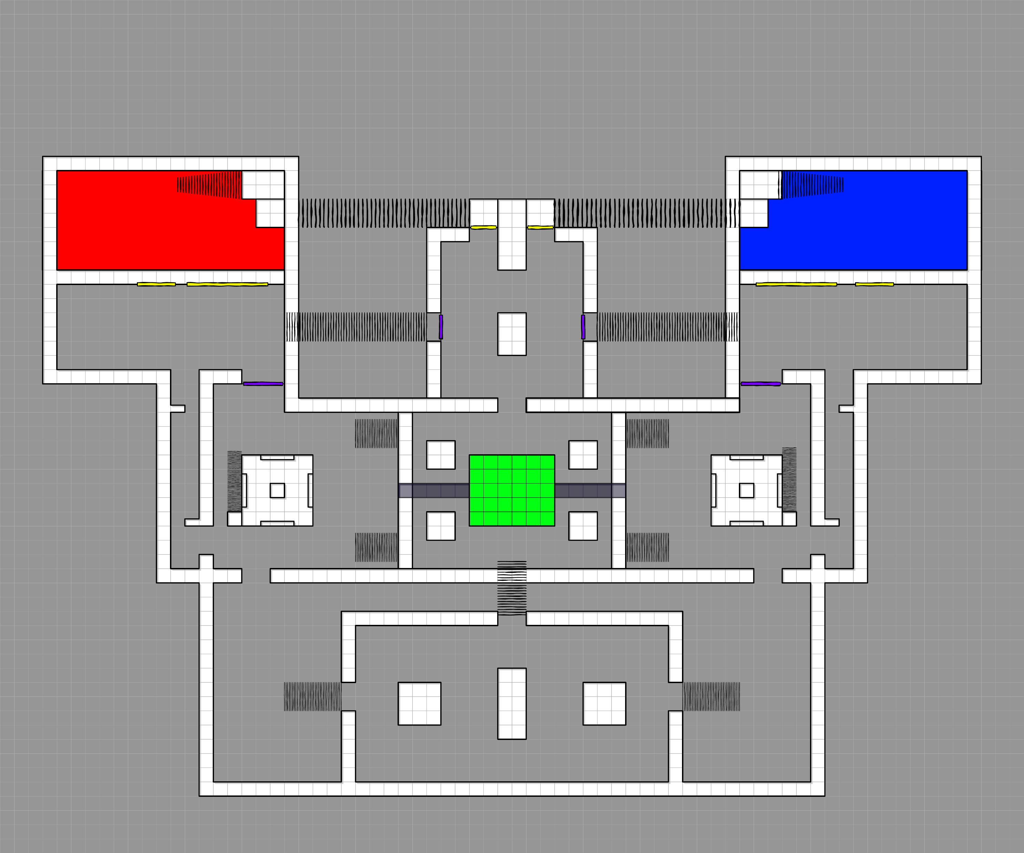

### Iteration #6 – Adding Levitation to Blue Room

#### [ Characters played ]





#### [ Feedback given ]

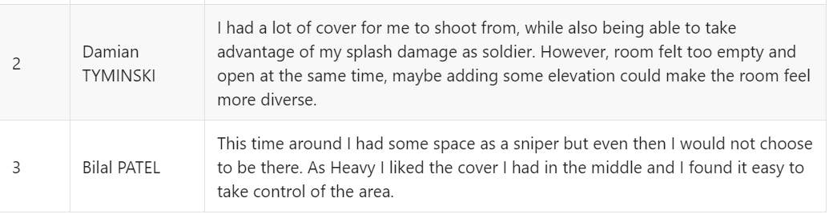

#### [ Feedback Overview ]

It seems like the size is not the issue with the room but instead it is the simple and cubic structure of the room that is. The feedback suggests adding elevation and unique layout.

#### [ Feedback Consideration ]

I added elevation to both sides of the room that players can get to, which should allow a little more interesting combat, angles. I also added cover in the center for players that are trying to get inside the room, this should encourage the players to leave the point and contest Blue Room. I want players to do that as I don’t want to just stand on the point which can get boring.

**[ Original ]**

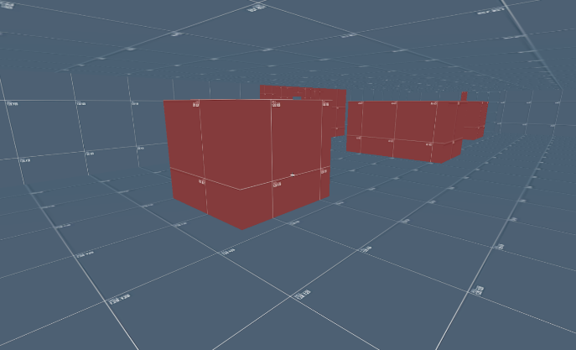

**[ Change ]**

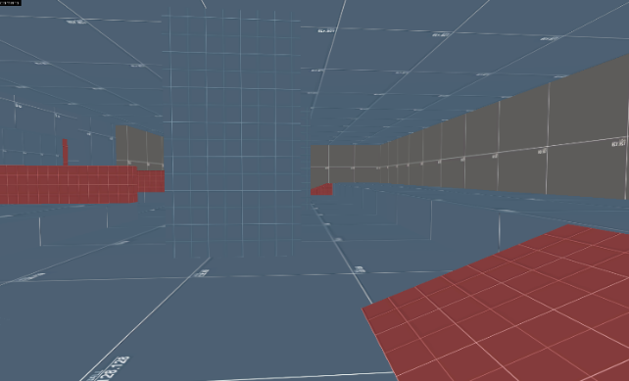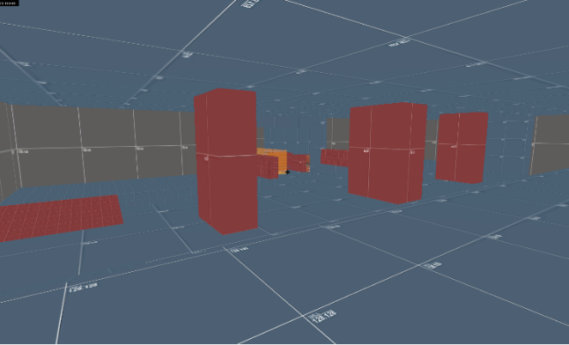

**[ Changes ] :**

* Elevation added.
* Covers in the middle of the room are now smaller.
* Added mini cover on the left side, for players entering the room from the center.

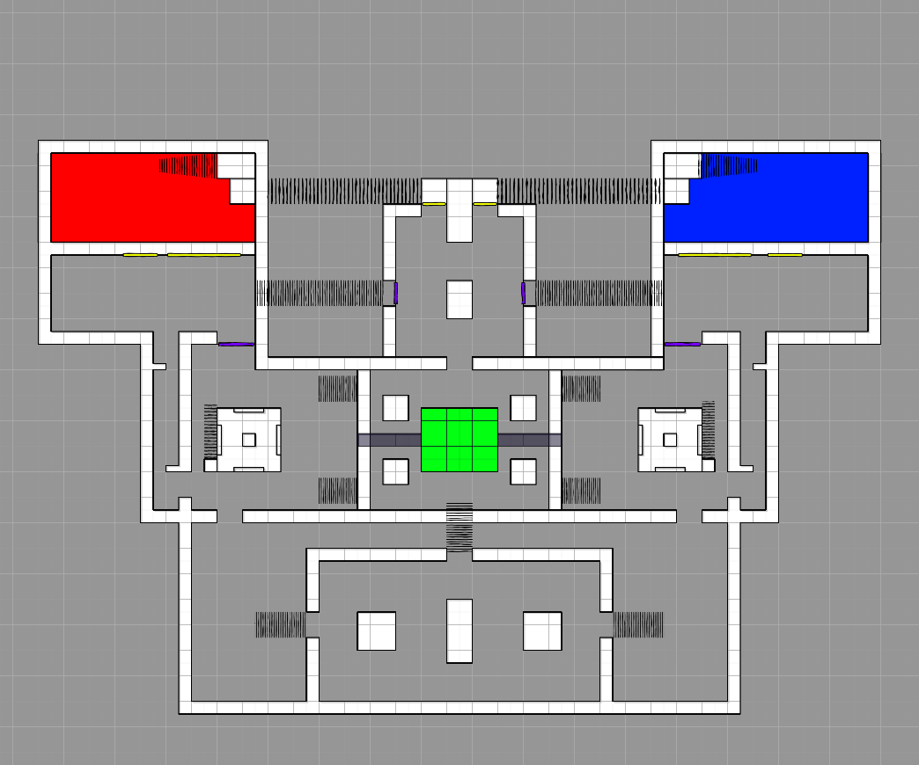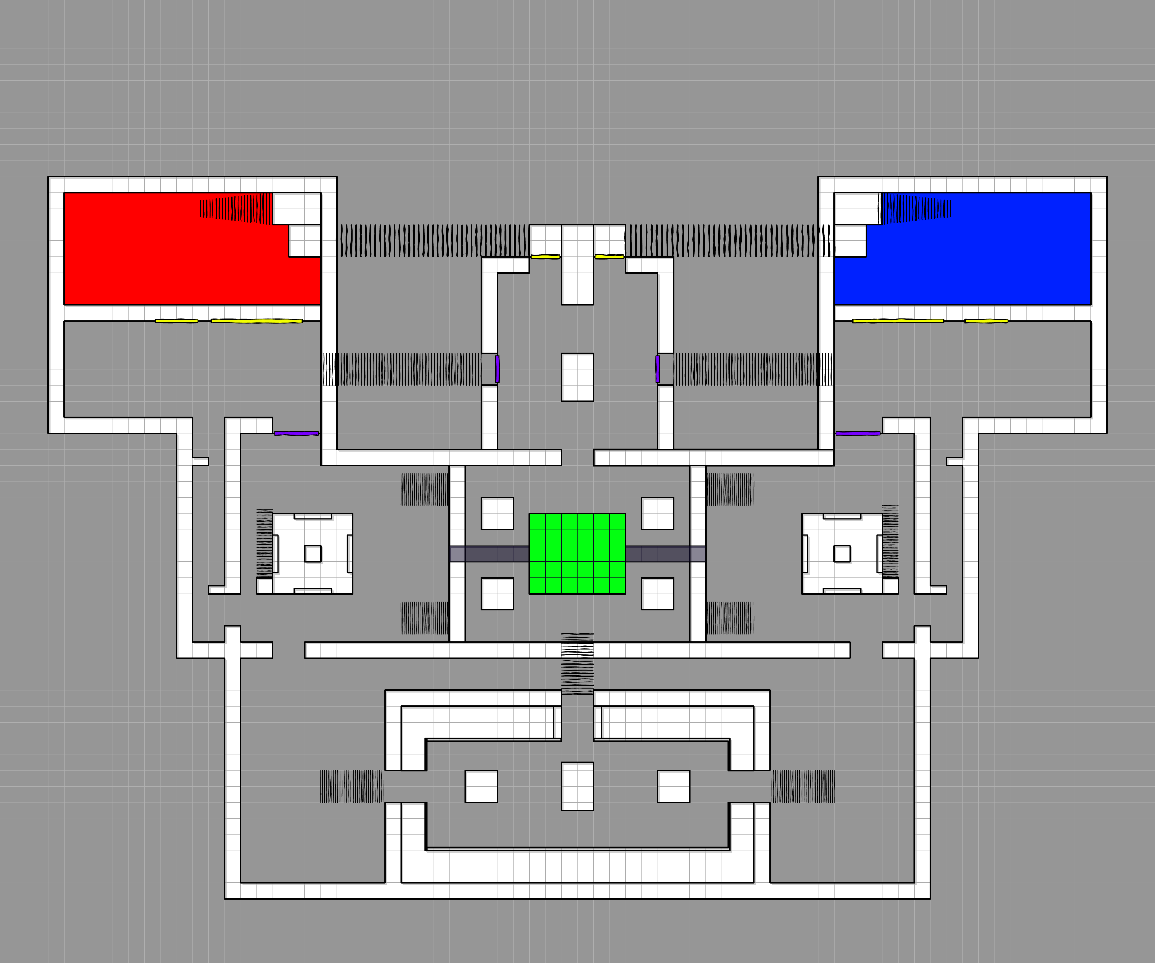

### Iteration #7 – Adding cover for Blue Flank area.

#### [ Characters played ]





#### [ Feedback given ]

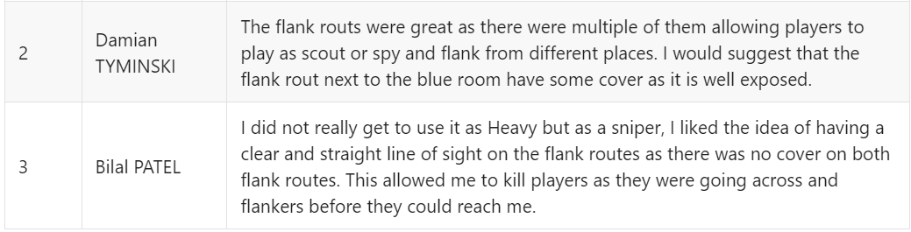

#### [ Feedback Overview ]

The feedback mostly suggested change for the Blue Flank, which is between the point and the Blue Room. It suggested adding some sort of cover for flankers. The sniper also suggested that the flank routes were nicely exposed for them to shoot at players before they can get to the Sniper. Characters like Scout can have hard time using space like this as they prefer more open space, although Spy would not have much of a problem, since they can go invisible. Other problem can be against a skillful Sniper who can shoot at enemies, while they are trying to get to Blue Room.

#### [ Feedback Consideration ] I felt that it was unfair to get shot across the map but at the same time, I did not want to take that opportunity away from sniper completely. So, I added some cover, this cover will make it harder for a sniper to time their shot when enemies across the map are trying to get into Blue Room. Additionally, the flankers can have some cover while flanking. Furthermore, this cover will also allow the players to climb to the point, allowing players that jump down accidentally to get back up and allow flankers to have multiple routes. Overall, this mini change has opened many possibilities.

**[ Original ] [ Change ]**

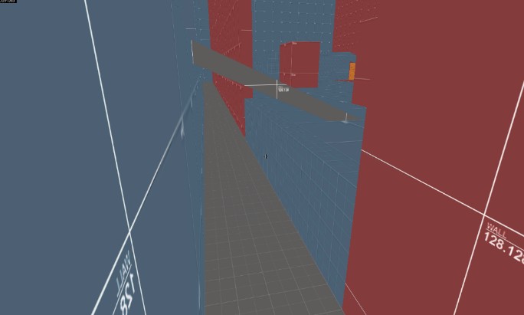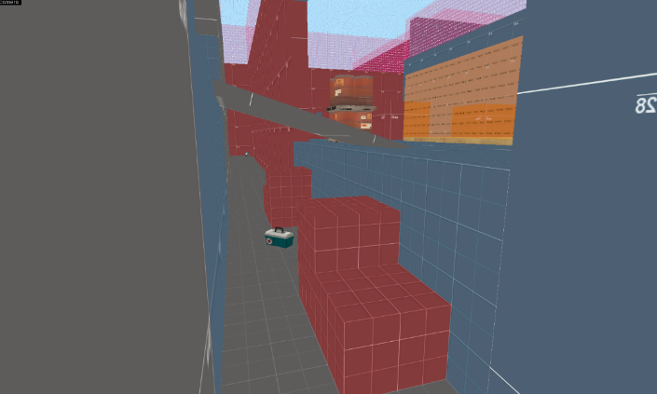

**[ Changes ] :**

* Added Boxes

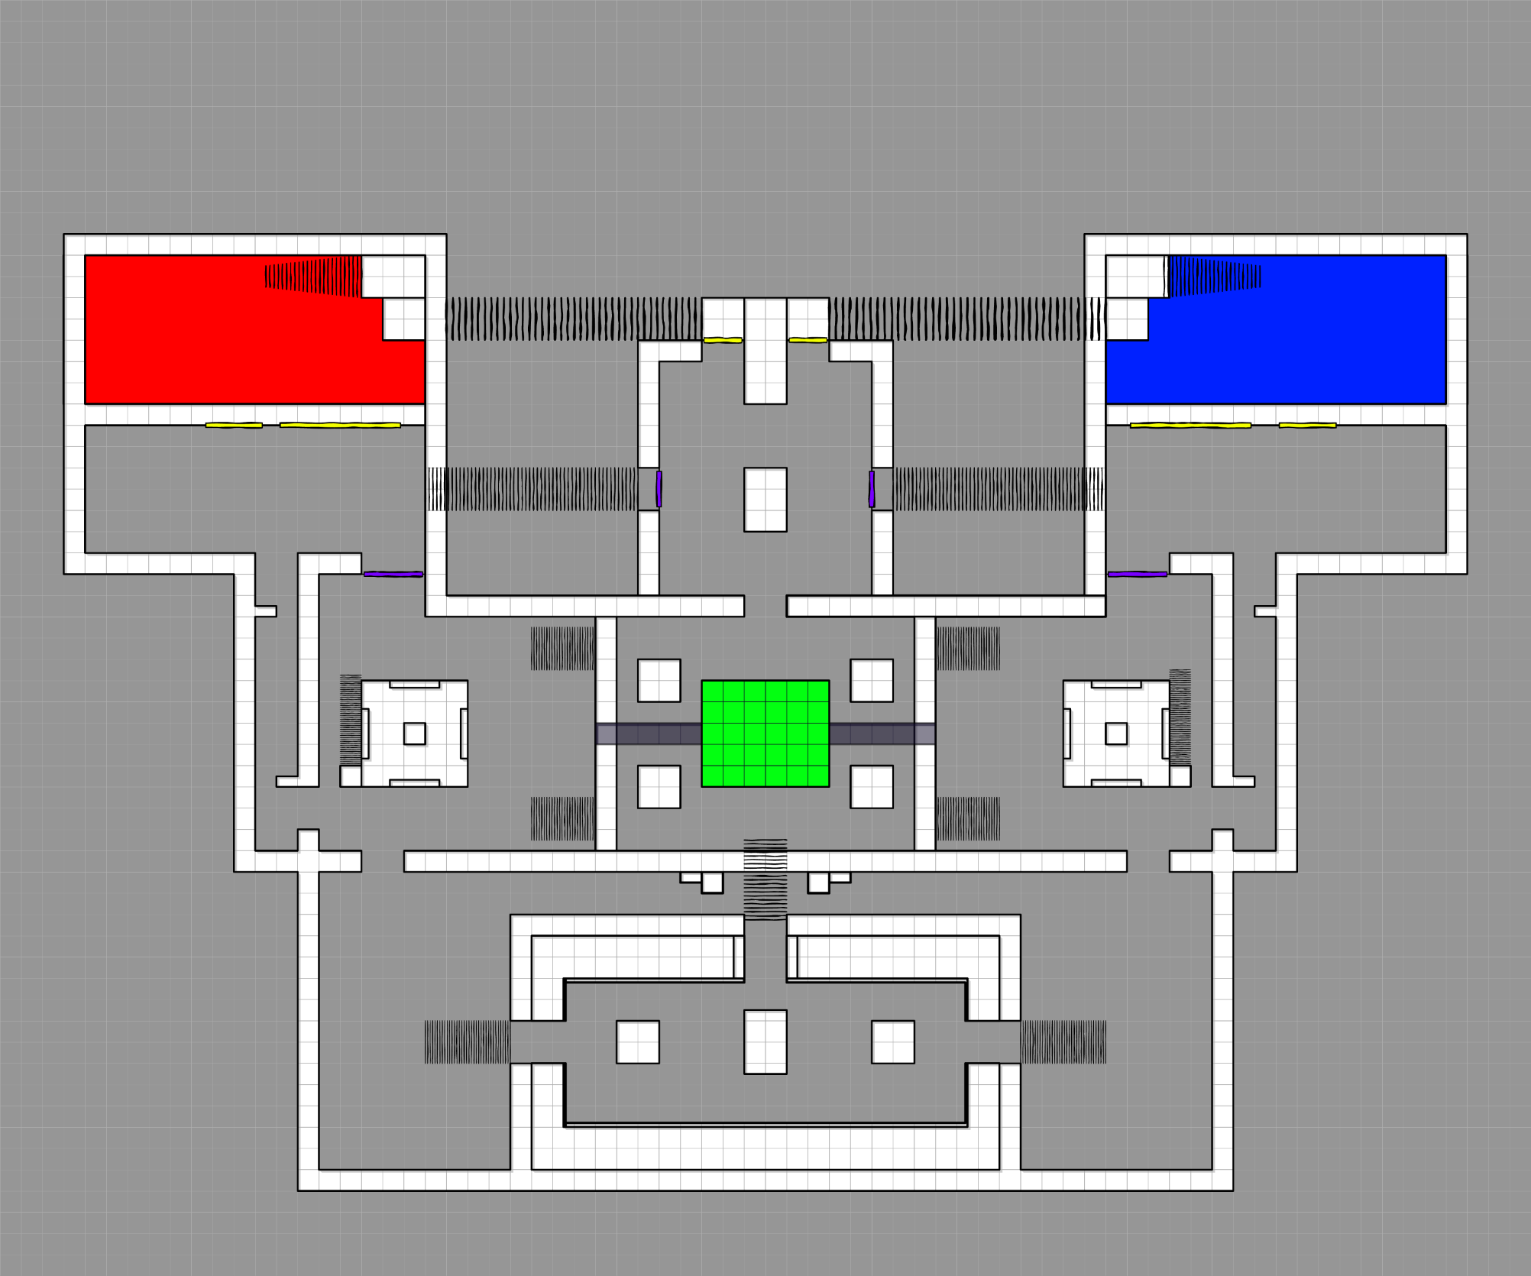

### Iteration #8 – Adjusting Pickup Position

#### [ My Consideration ]

Finally, after making the final adjustment I changed the pickups position slightly, although I still tried to keep them between the point and the spawns. Additionally, I got rid of two small ammo packs next to the point, as when comparing my number of pickups with existing maps, I realized that I had too many pickups.

Spawn Supply

Medium Ammo

Medium Health kit

Small Ammo

Large Health kit

**Inside the tower**

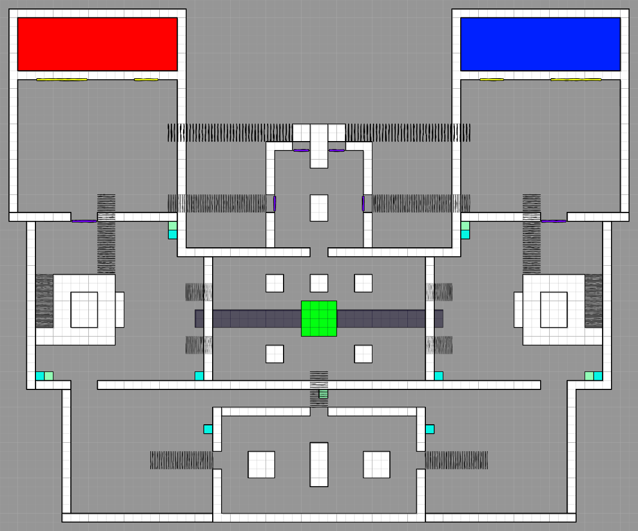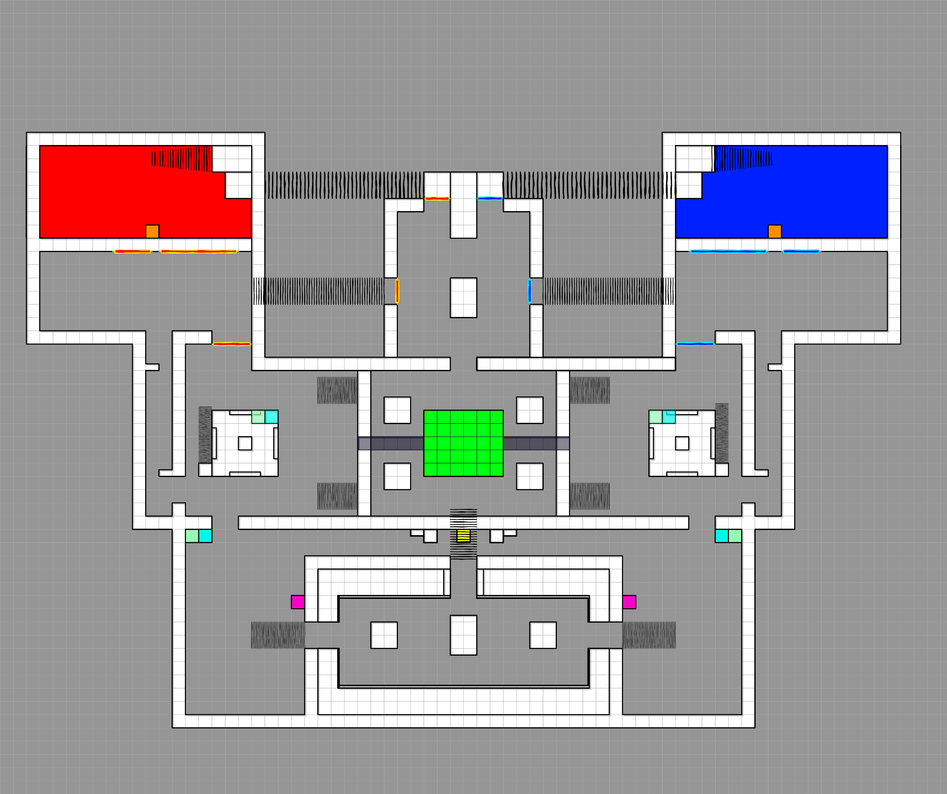

### Iteration #9 – Adding Blockage to the edge of Mini-Tower

#### [ My Consideration ]

After playtesting as Sniper, I found it a little annoying that I kept on falling from the Mini-Tower because there was no blockage or anything to stop the Sniper from accidentally falling off and getting into a bad position. To prevent that from happening I added small blockage, that will still allow the sniper to jump off the Mini-Tower when needed to.

**[ Original ] [ Change ] Added Blockage**

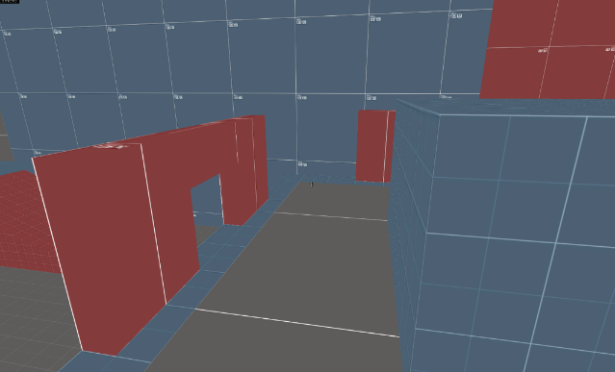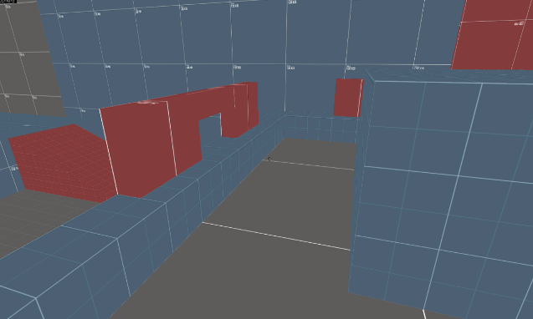

### Iteration #10 – Adjusting Point Cover

#### [ My Consideration ]

Further problem I found was being able to see enemies head even if they were behind the cover, I found it to be unfair, as I wanted Sniper to have impact on the point but at the same time, I did not want the players on the point to continuously worry about sniper and perfectly position themselves, since that did not meet the TF2 play style.

Fixing it was simple as I just made the cover larger and little wider, this provided some comfort for the players on the point, however it did not eliminate the idea of players having to be careful with their position, I am fine with that as I still want Sniper to have opportunity to hit enemies.

**[ Original ] [ Change ]**

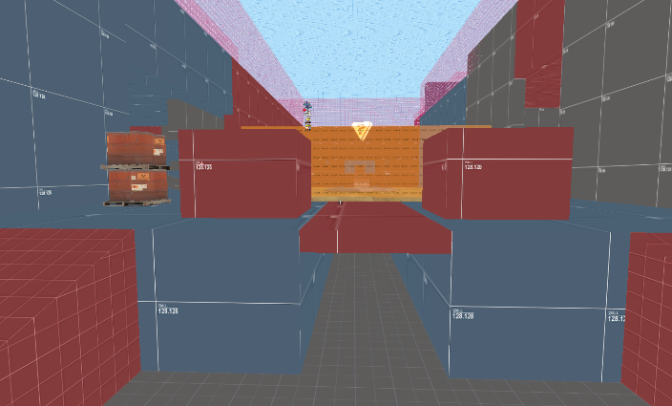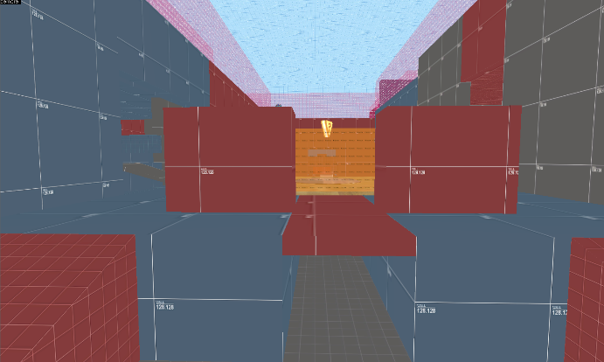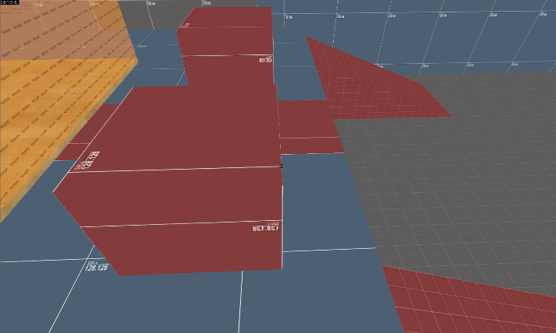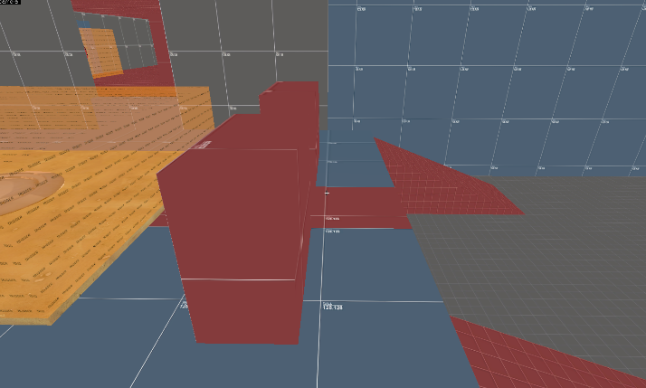

### Iteration #11 – Blue Room Adjustment

#### [ My Consideration ]

During play testing I noticed that a lot of blue room space was not being used, that was because players were focusing on the point a lot more, and this also made the back side of the room feel long and empty.

To make the room better I decided to shrink the back side of the room. This will not change anything regarding how the room was being used before since I only got rid of the extra space that was not being used. Additionally, the room structure now allows player to mainly focus on the point, and that is what the game mode is about.

**[ Original ] [ Change ]**

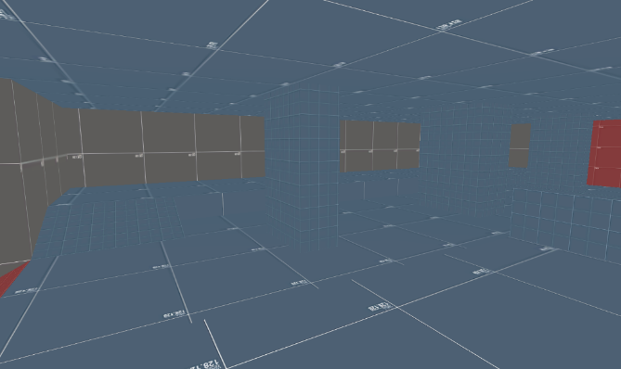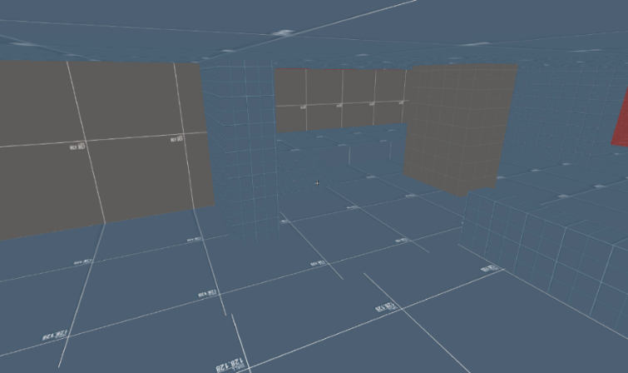

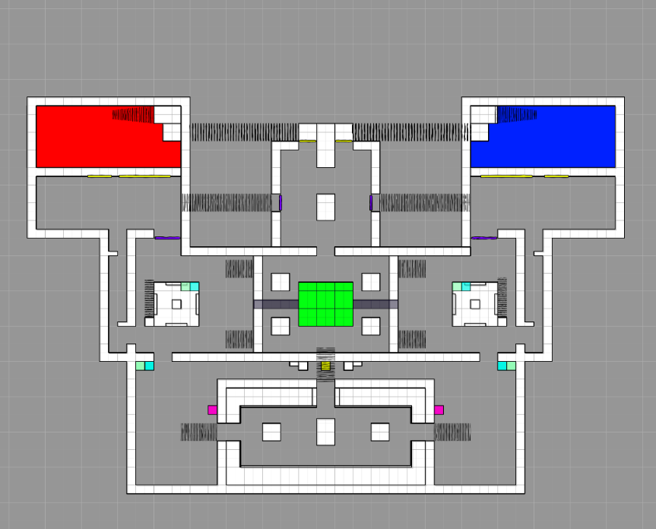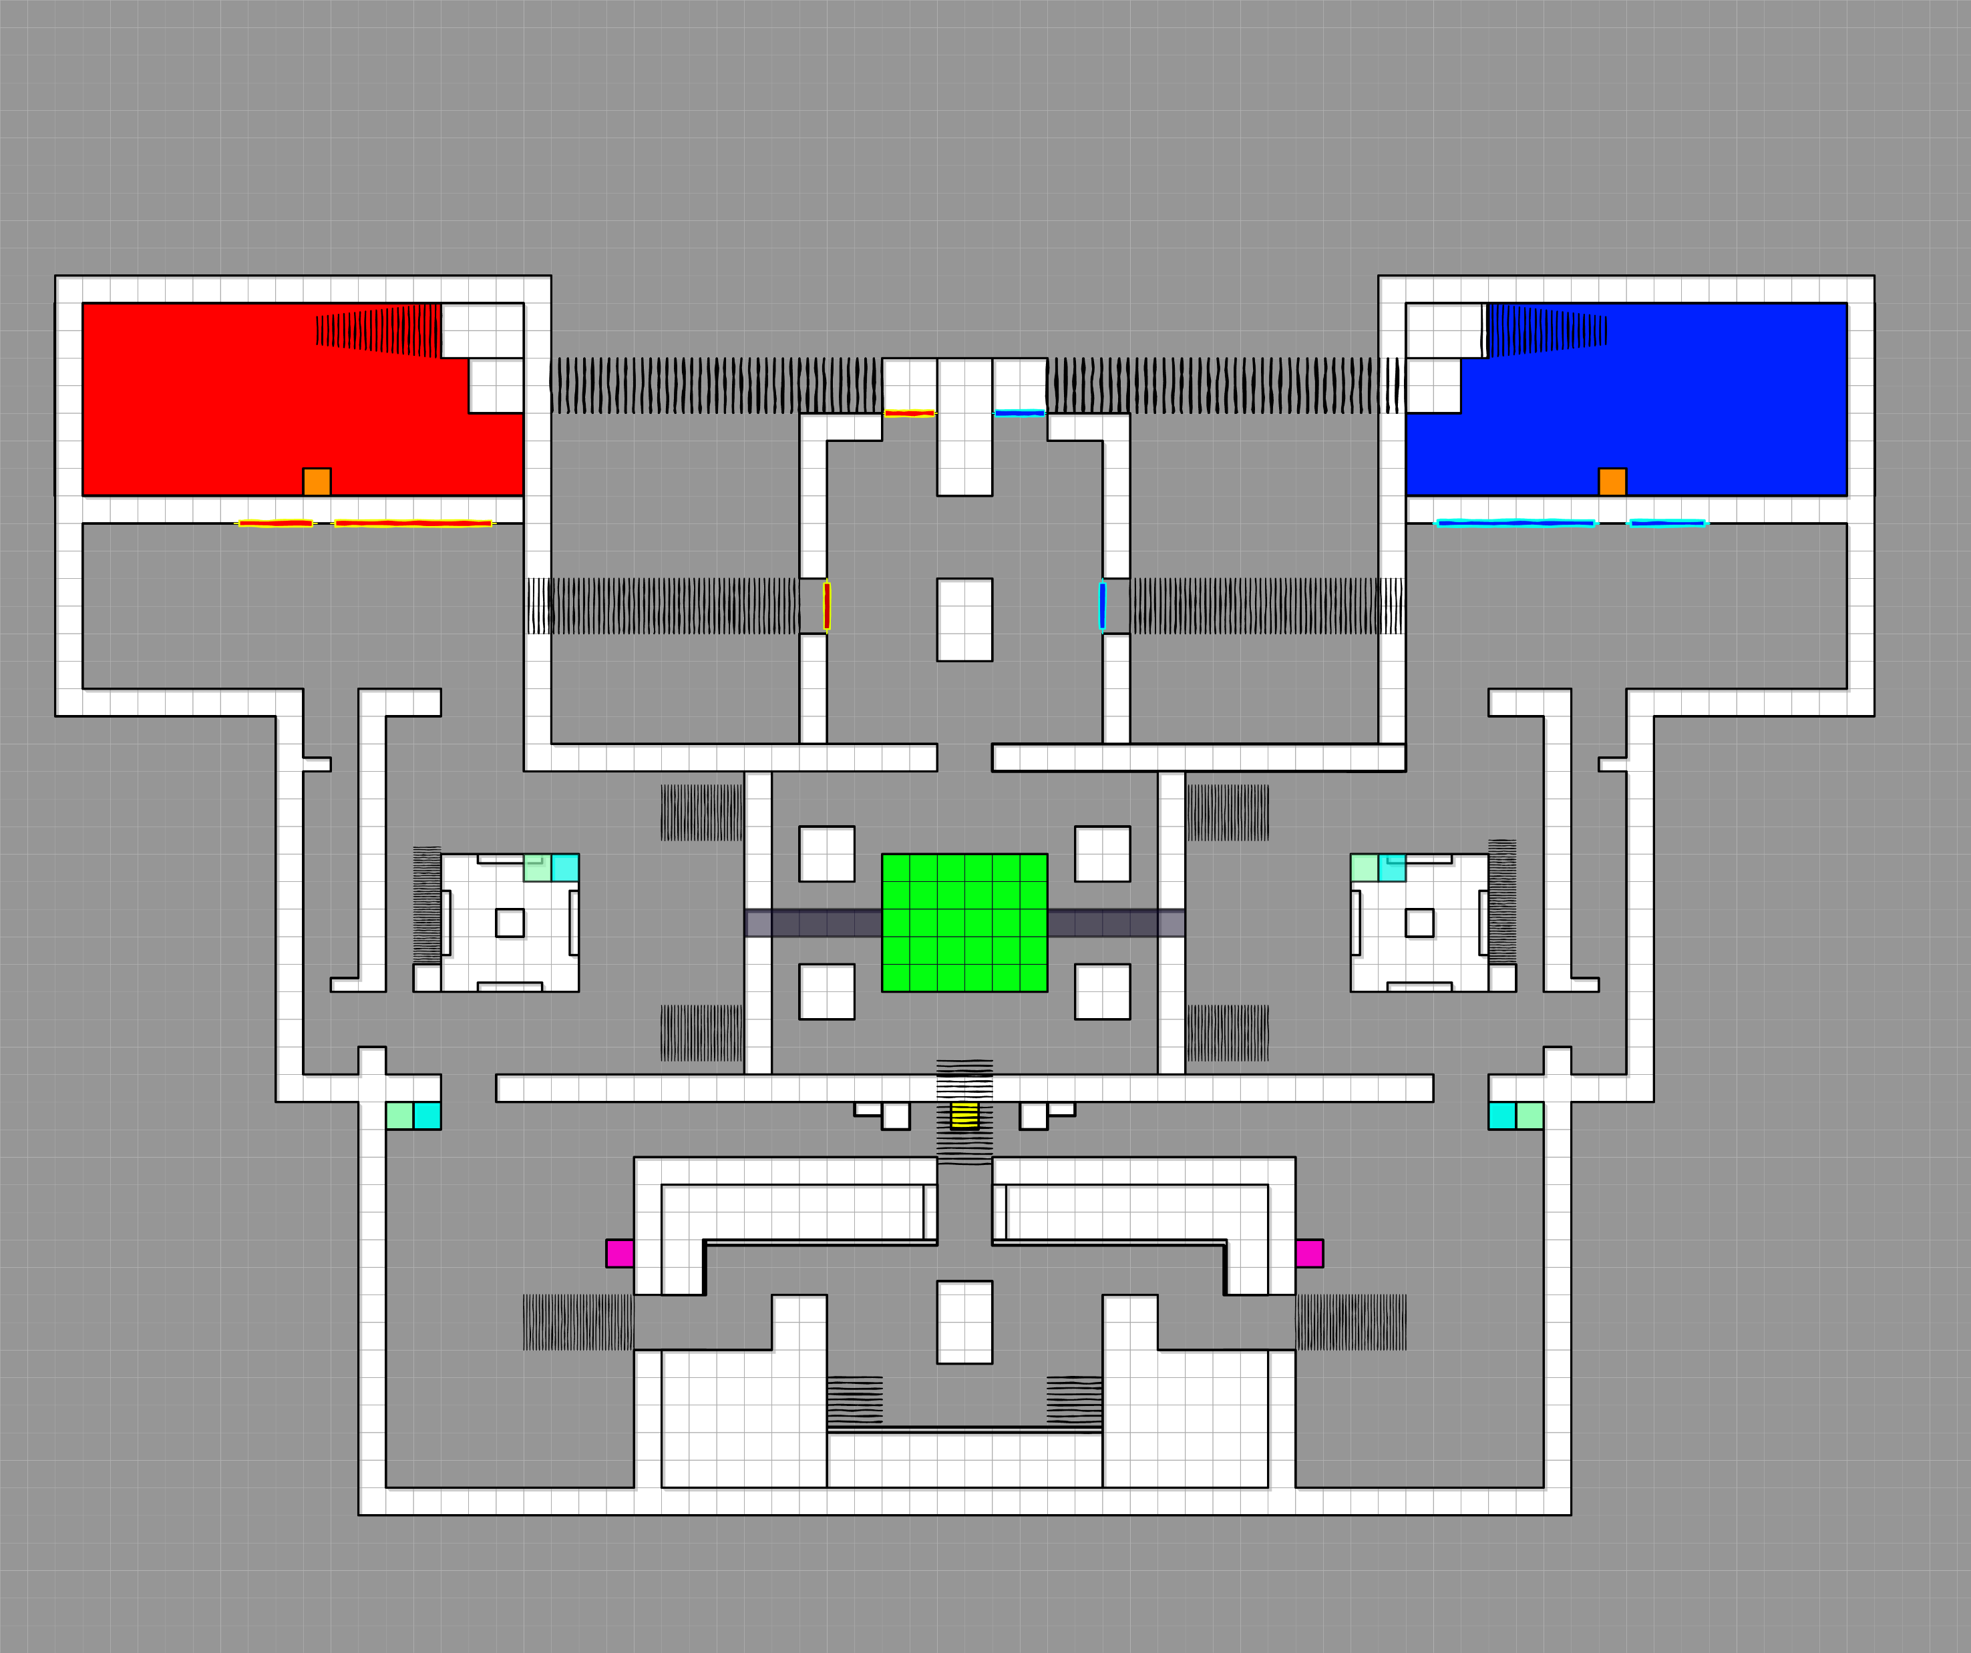

### Iteration #12 – Removed the Main Entrance Door

#### [ My Consideration ]

I got rid of the door as it was not needed, the opposing team never managed to get close enough to spam the spawn exit, even if they could there are still multiple exits for players to take to prevent spawn camping.

**[ Original ] [ Change ]**

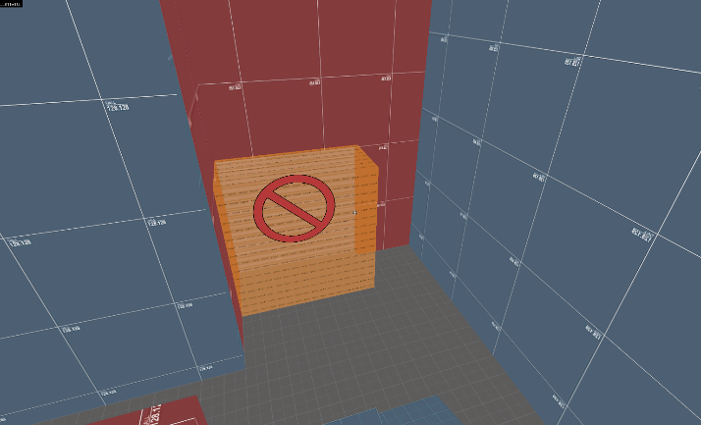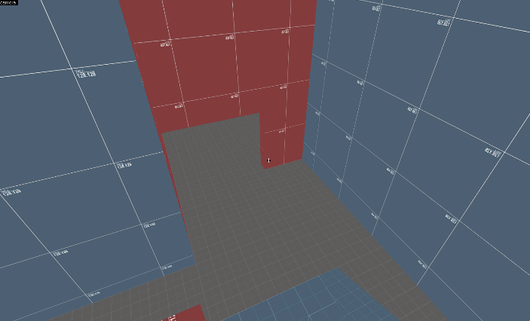

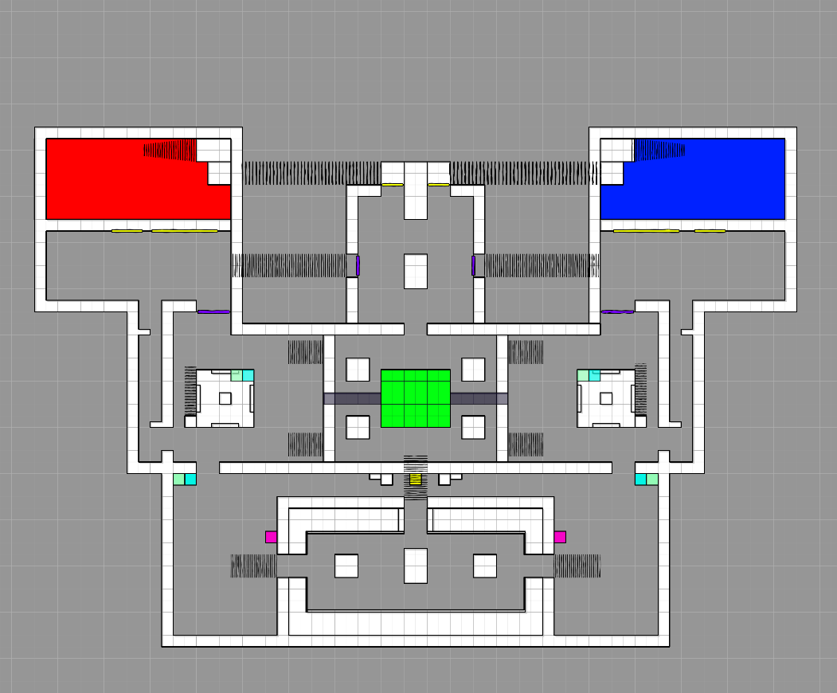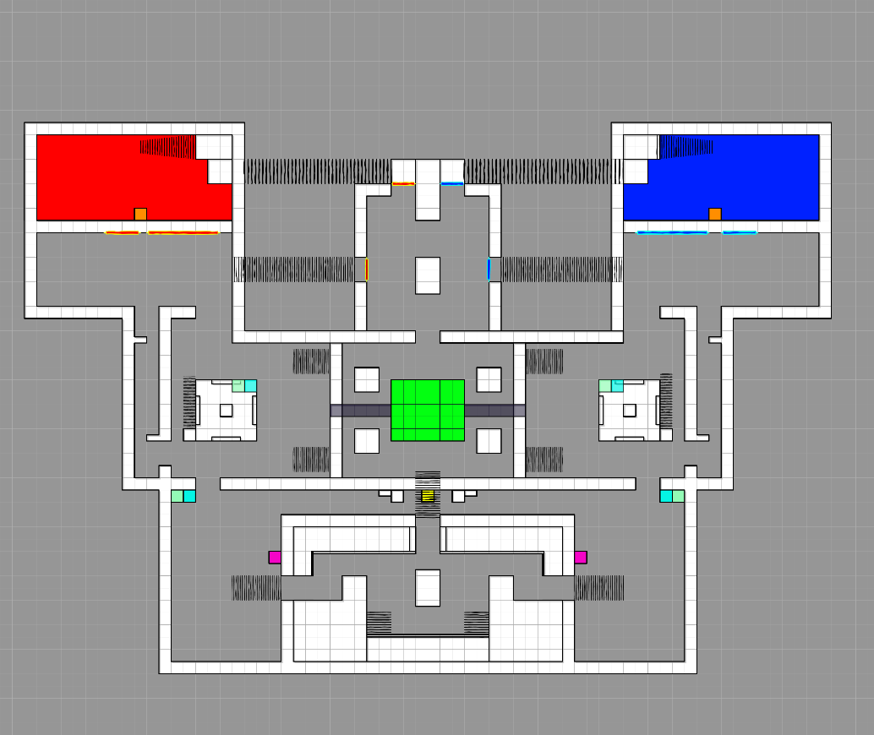

### Iteration #13 – Making Red Room Smaller

#### [ My Consideration ]

After making the blue room smaller by getting rid of not needed space, I realized that the red room did not feel as small as it should be, it is also the room that I did not scale down compared to all the other area of my map. I decided to bring down its length and make it a perfect square. This will also make the characters like Pyro and Demoman priorities the red room over blue room, just like it was intended.

**[ Original ] [ Change ]**

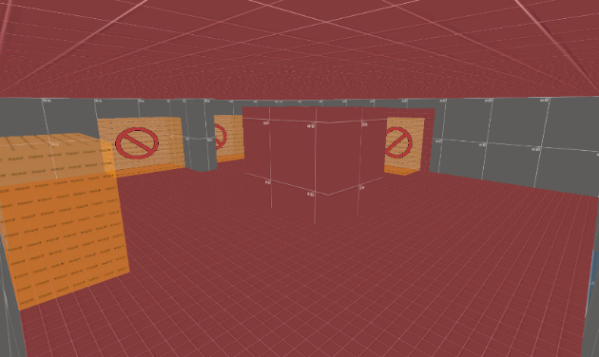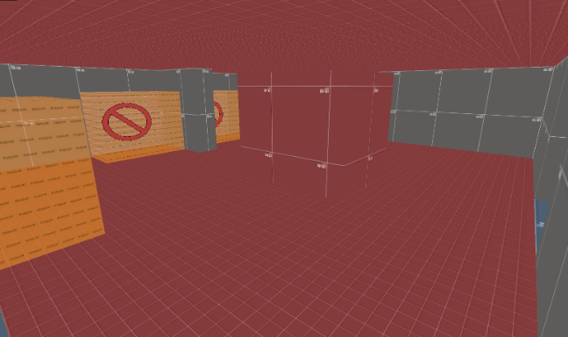

**[ Changes ] :**

* **Red Room Size reduced.**

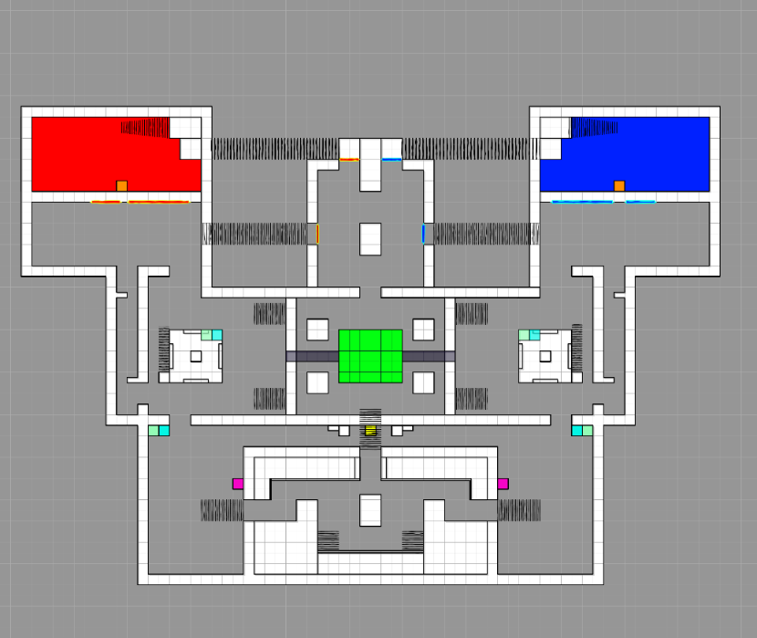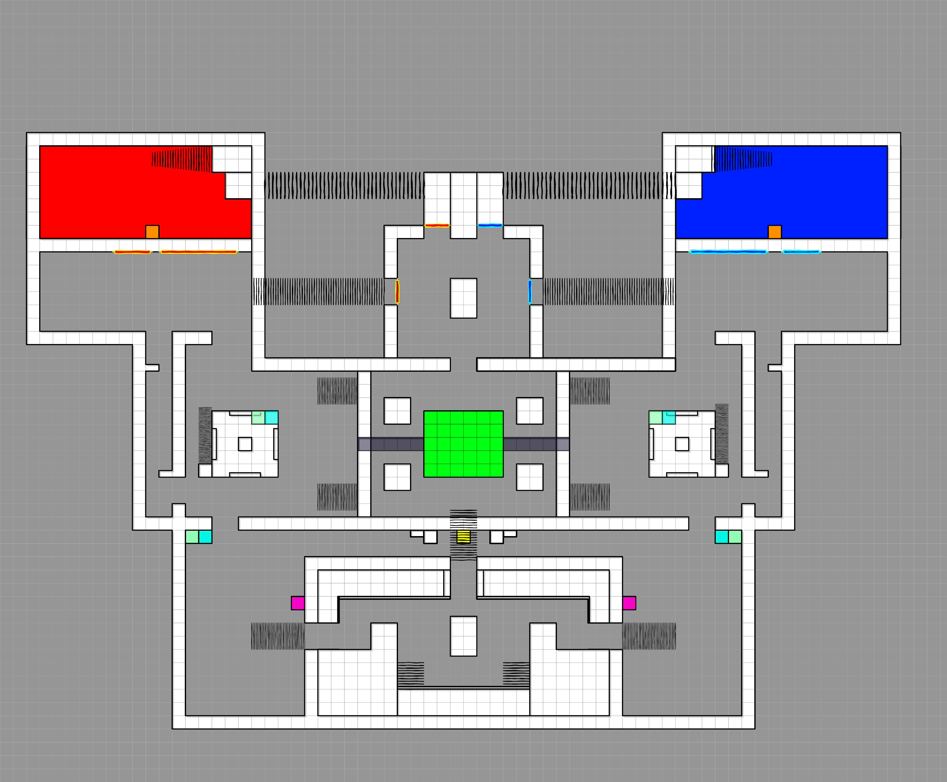

### Iteration #14 – Filling Empty Spaces

#### [ My Consideration ]

Some part of my map felt too open with space that was not needed, during play testing I noticed that no one would go there and overall, those empty spaces made the map feel too bulky or square. To get rid of the extra space I simply added walls with somewhat unique shape. I may change these later and replace them with nice meshes that represent things such as mountain.

**[ Original ] [ Changes ]**

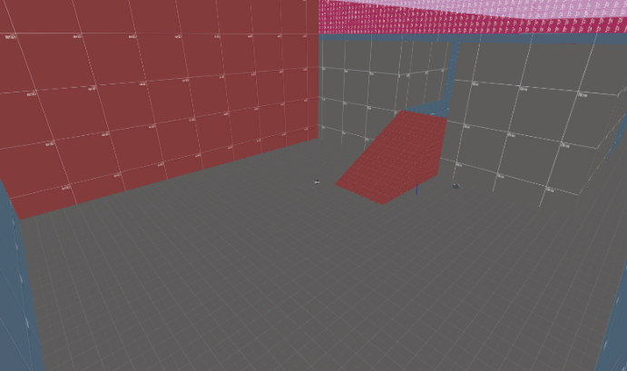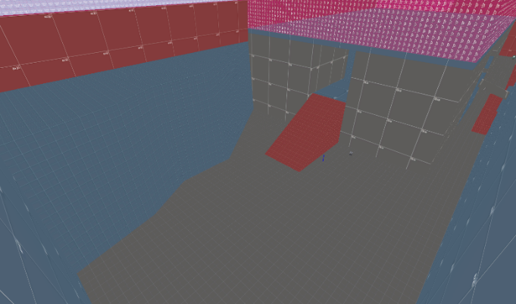

**[ Original ] [ Changes ]**

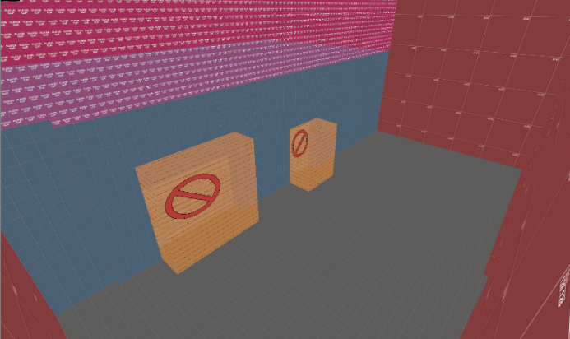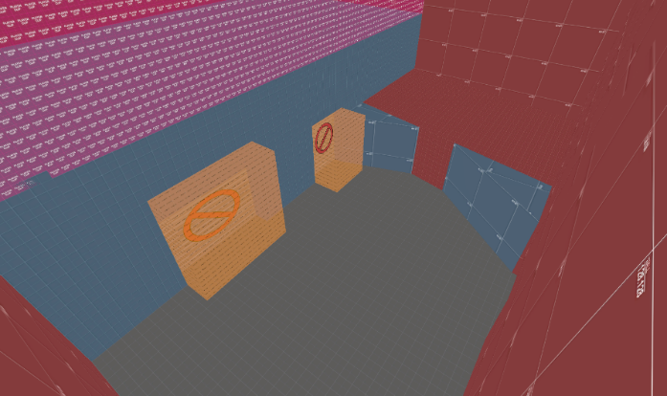

**[ Change ] :**

* Spawn room area covered.
* Empty space next to blue room covered.

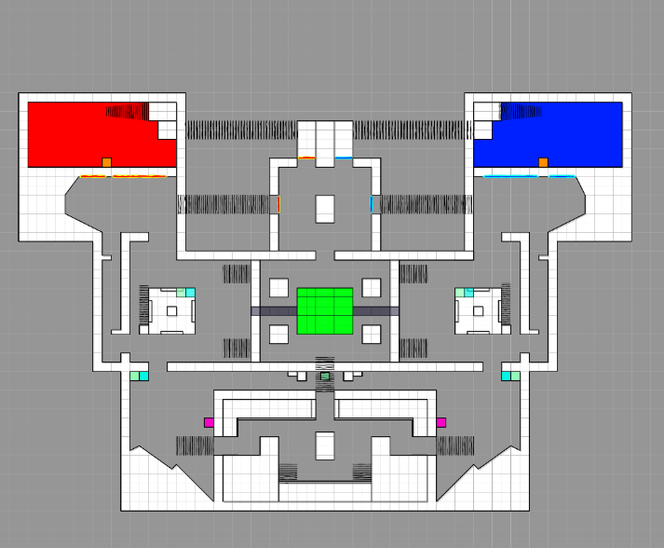

### Iteration #15 – Changing the Full Health kit to Medium.

#### [ Characters played ]



#### [ Feedback given ]



#### [ Feedback Overview ]

The feedback suggests that the Full Health Kit to be changed to medium, considering this player was playing Heavy and the other feedback I have received suggest that I should change it to medium such as:



There were no medic and even then, the Heavy were able to hold their ground, without having to go to spawn or leave the point to get other pickups.

#### [ Feedback Consideration ]

I did further test and realized that the Full Health Kit Spawns every 10 seconds. Which made them really overpowered, so I decided to replace it with Medium Health Kit. Especially since it is right next to the point.

**[ Original ] [ Change ]**

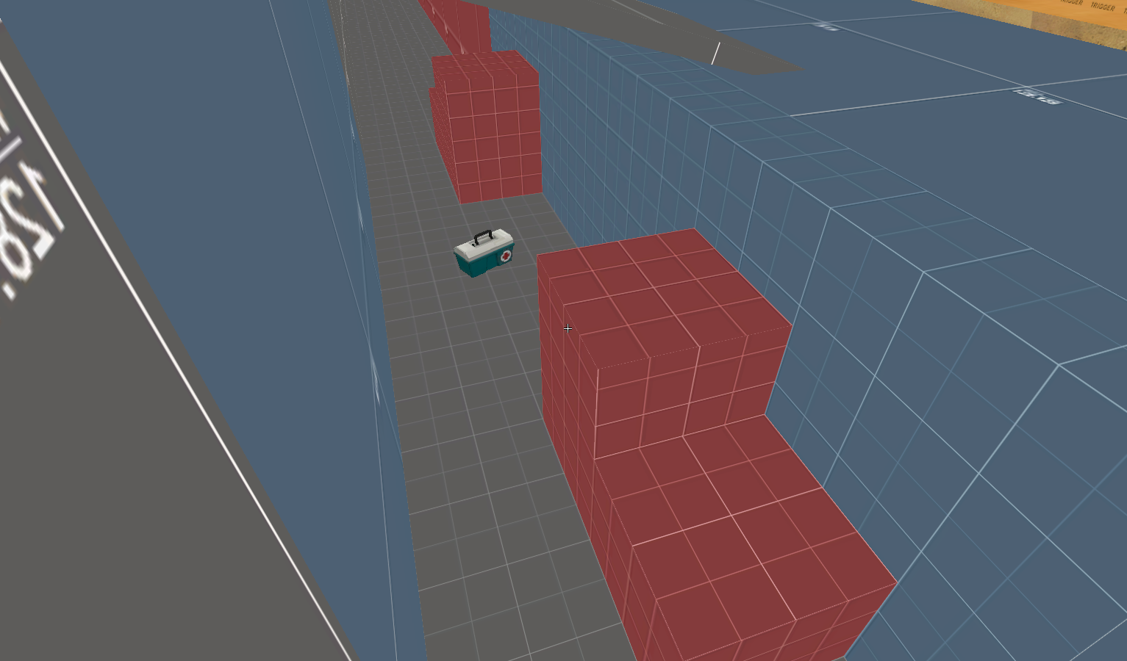 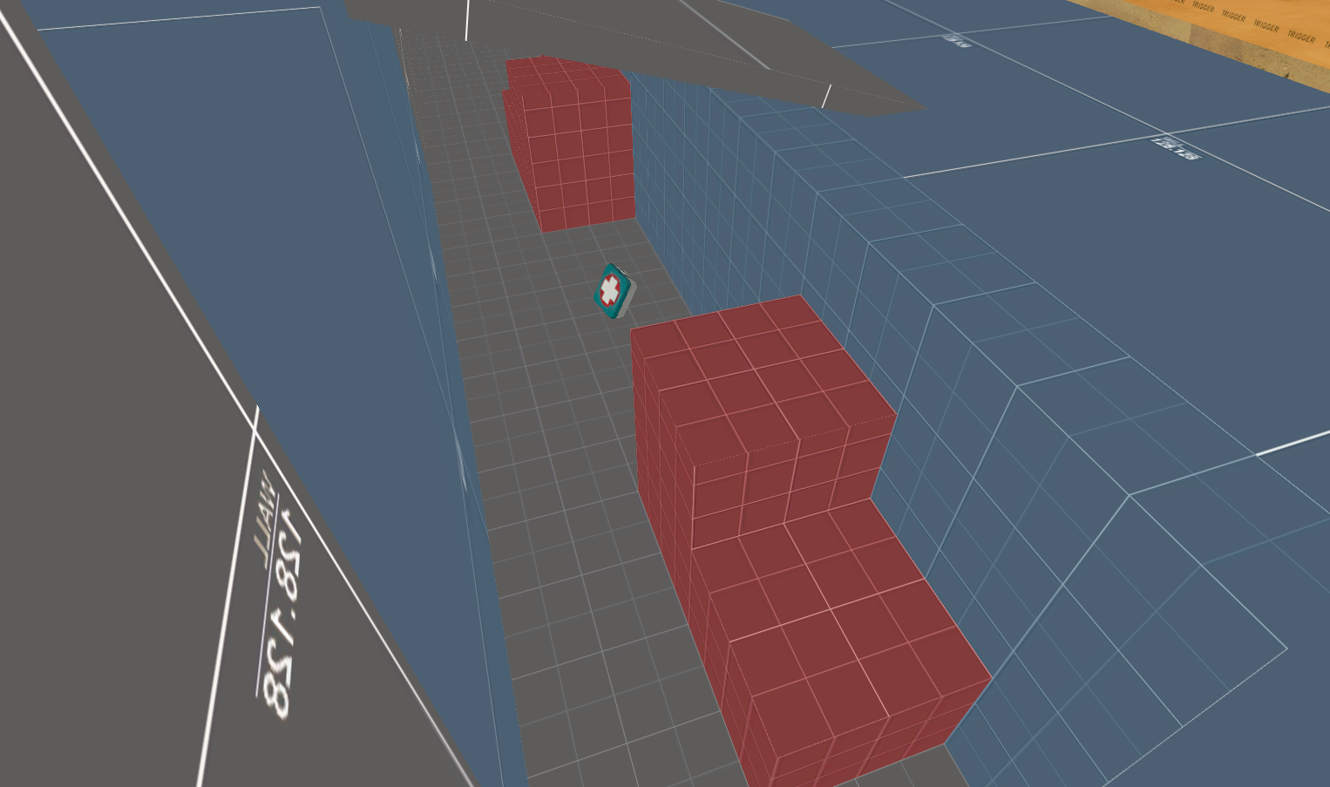

### Iteration #16 – Added Direction Signs.

#### [ Characters played ]



#### [ Feedback given ]



#### [ Feedback Overview ]

After watching the play test and seeing players feedback, I can see that players were a little confused about where they were heading or needed to go.

#### [ Feedback Consideration ]

I decided to Add signs that will help guide the players towards the point, this will help reduce confusion, especially since I have too many routes that players can take from spawn.

**[ Original ] [ Change ]**

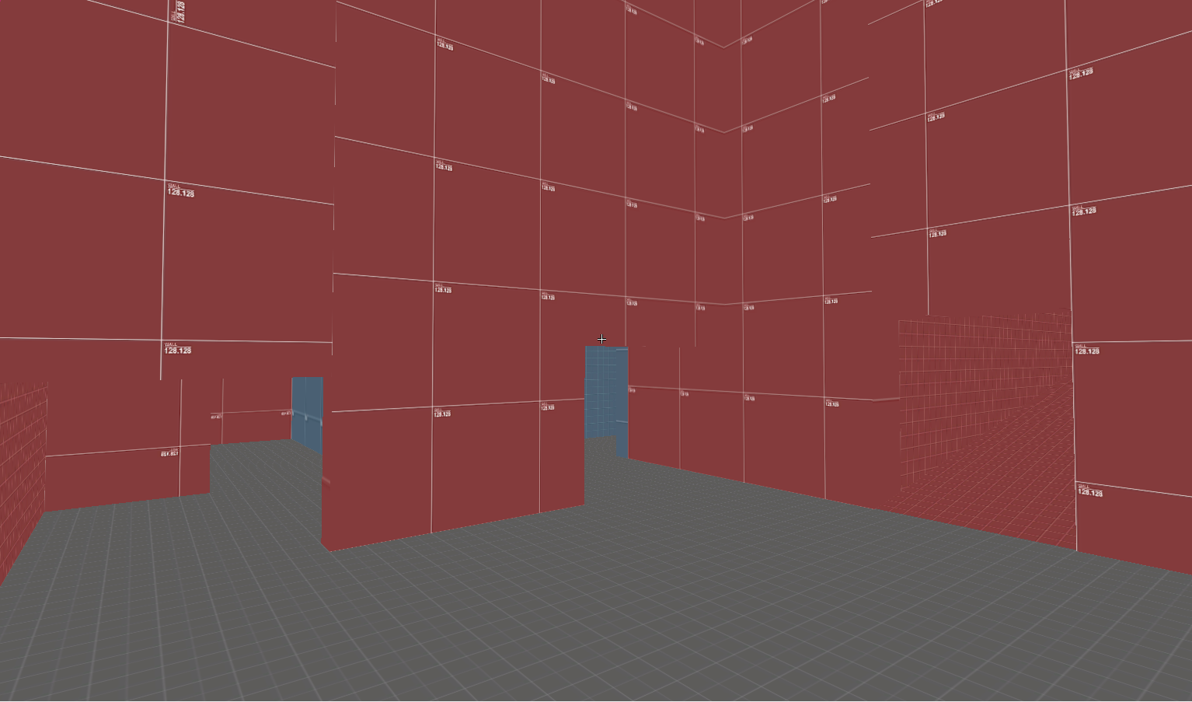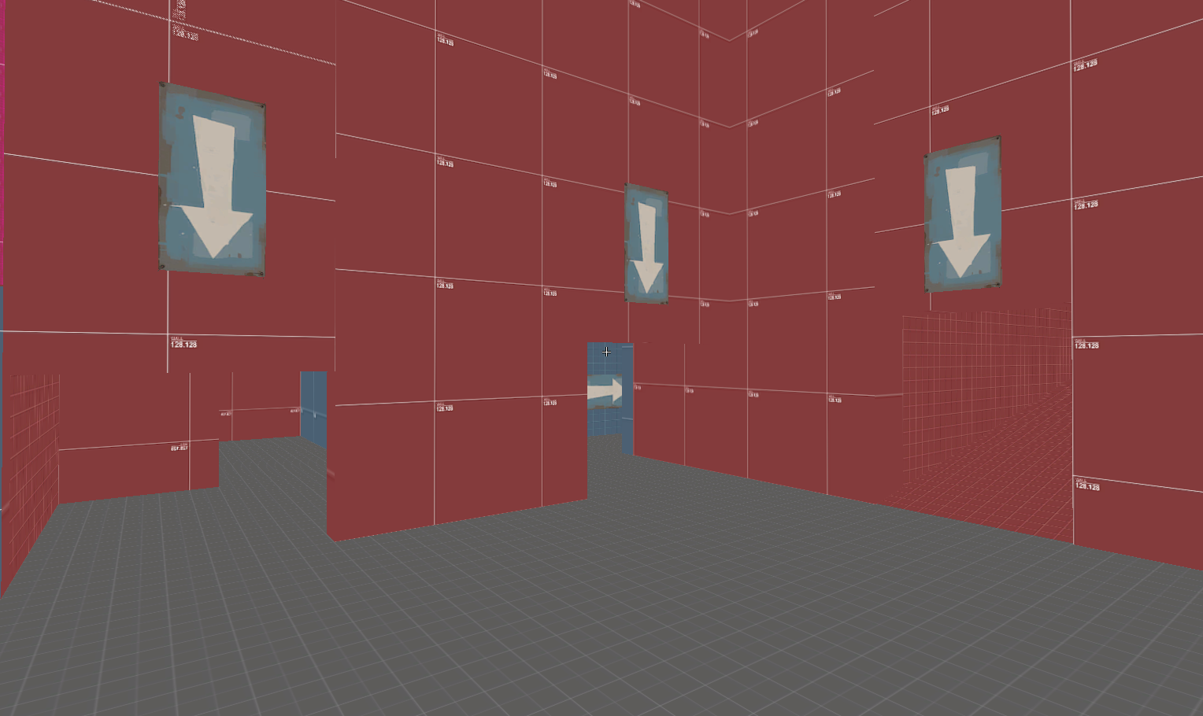

## Erroneous data

### Data # 1

#### [ Characters played ]



#### [ Feedback given ]



#### [ Feedback Review ]

This feedback suggest that Heavy characters were dominating the point and retaking the point was hard. That is to be expected if players are just going to the point and not utilizing the side rooms. The structure of the map is purposely made that way, so that players make use of other part of the map to capture the point.

The testing was also done as 3 vs 3, which does not provide a normal Tf2 gameplay, as the map is designed for 12 vs 12. However, I still took this feedback into consideration and made the rooms more point focus, my shrinking them changing their structure. (the work is shown in the iteration #13, #11)

## Zoning Table 1

### Keys – Areas Characters would use the most.

**Go to Sometimes**

**Would rather not go to**

**Go to Often**

#### [ Expectation ]

|  |  |  |  |  |  |  |
| --- | --- | --- | --- | --- | --- | --- |
| **Expectation** | **Red Room** | **Blue Room** | **Tower** | **Enemy Tower** | **Point** | **Flank Routes** |
| **Scout** |  |  |  |  |  |  |
| **Spy** |  |  |  |  |  |  |
| **Soldier** |  |  |  |  |  |  |
| **Demoman** |  |  |  |  |  |  |
| **Pyro** |  |  |  |  |  |  |
| **Heavy** |  |  |  |  |  |  |
| **Medic** |  |  |  |  |  |  |
| **Sniper** |  |  |  |  |  |  |
| **Engineer** |  |  |  |  |  |  |

#### [ Actual Result ]

|  |  |  |  |  |  |  |
| --- | --- | --- | --- | --- | --- | --- |
| **Expectation** | **Red Room** | **Blue Room** | **Tower** | **Enemy Tower** | **Point** | **Flank Routes** |
| **Scout** |  |  |  |  |  |  |
| **Spy** |  |  |  |  |  |  |
| **Soldier** |  |  |  |  |  |  |
| **Demoman** |  |  |  |  |  |  |
| **Pyro** |  |  |  |  |  |  |
| **Heavy** |  |  |  |  |  |  |
| **Medic** |  |  |  |  |  |  |
| **Sniper** |  |  |  |  |  |  |
| **Engineer** |  |  |  |  |  |  |

#### [ Result Overview ]

Turns out players were not making use of the rooms at all as they would just go straight to the point. This is not how I wanted my map to feel like, as I wanted my map to be split for the most part. For example, Pyro and Demoman having easier time taking control of the Red Room as that room is small, however, they would just go to the point and not utilize the rooms, although this makes sense since why be in Red Room or Blue Room when the point is where you need to be.

Although I am happy to see that Sniper did make use of the Tower as it indicates it was a useful spot for the Sniper to be in. The same goes for Spy and Scout as they also utilized the flank routes.

##### **[ Evidence ]**

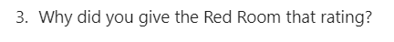



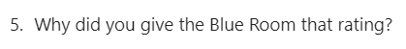

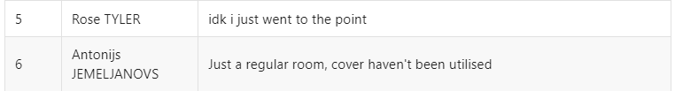

# Playtesting 2

## Testing Plan

### Overview

During this play testing I wanted to know more specific information such as if the rooms were being used, or if the point needed more cover. The idea was to ask questions about things that I was not sure if needed changes as well as confirm that the changes I have made had improved the gameplay.

### Plan

Here I did the same as my first play test asked questions to see what characters were played to later see what characters the feedback were refereeing to.

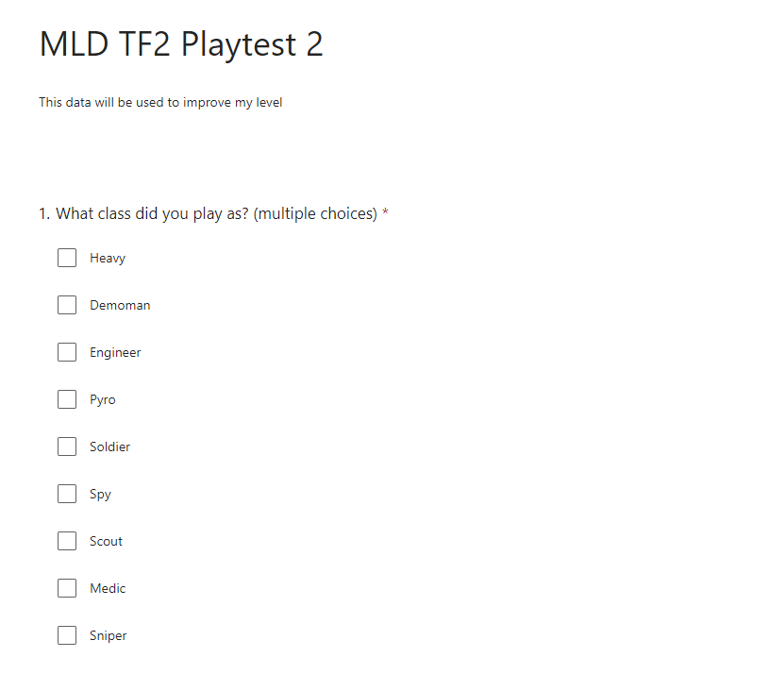

Here I wanted to know if players were using the Red and Blue Rooms as during first playtest player did not use it much at all. I also wanted to know if the rooms felt balance or had any impact on the point.

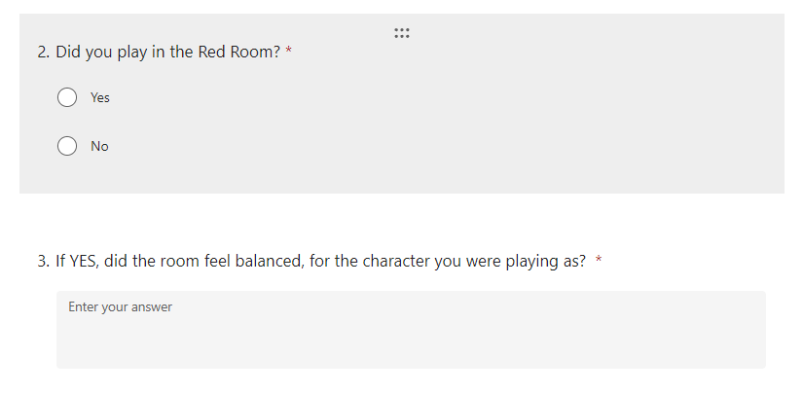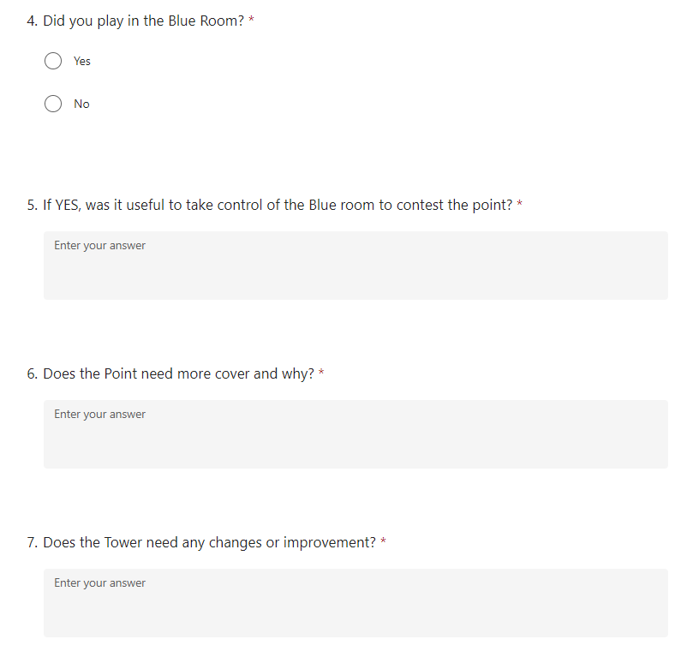

One of the things I was concerned about was the map travel time from spawn to point was little faster compared to other official maps, so I decided to ask players opinion to see if it felt fast or not.

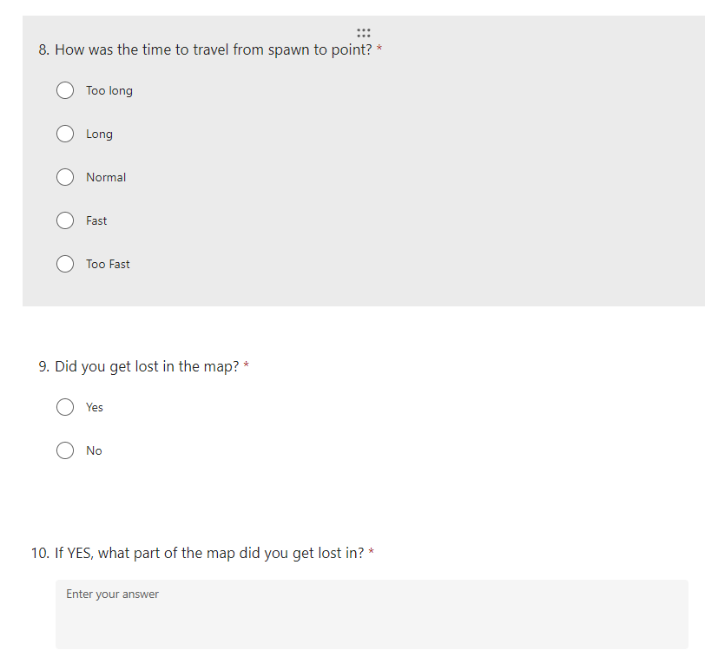

Here I wanted to know if players were getting lost on the map, since during my first play test I received feedback indicating that players were getting lost on the map.



I ended my questionnaire with general questions regarding the map.

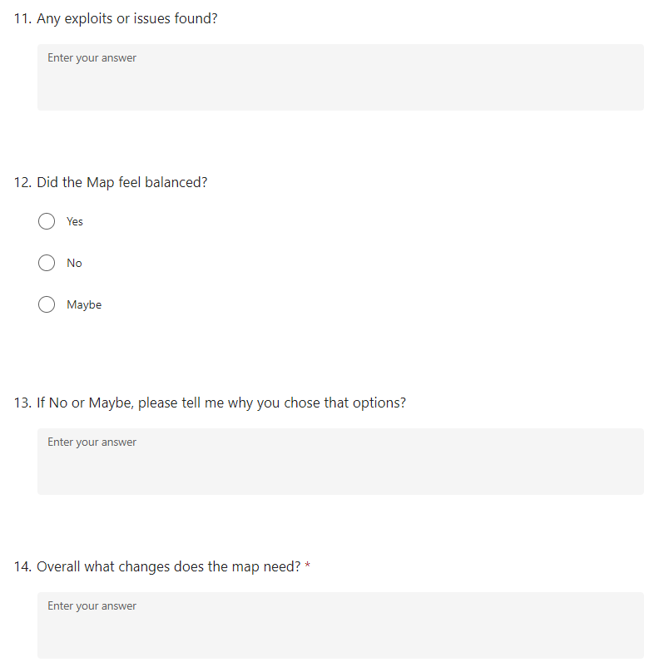

## Testing Results

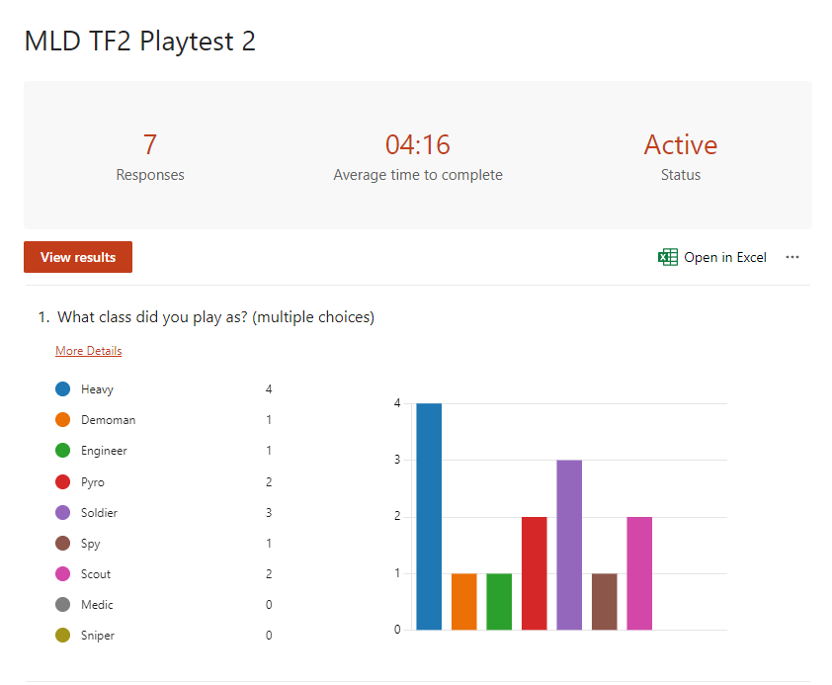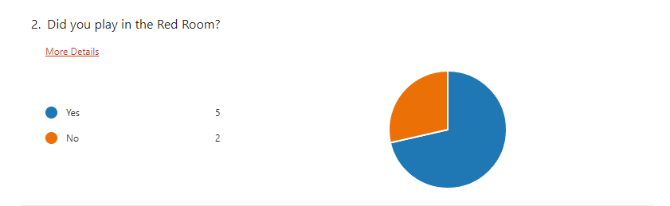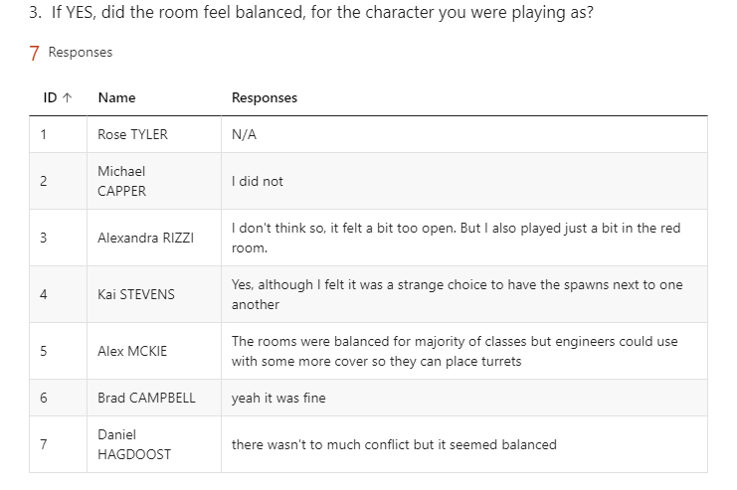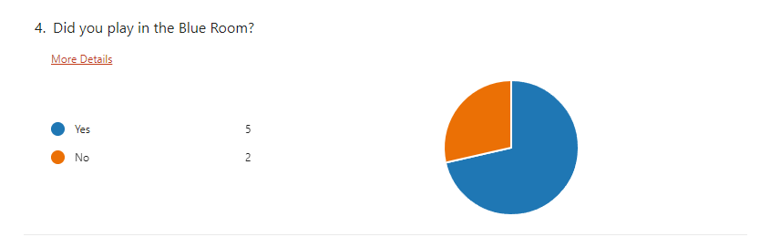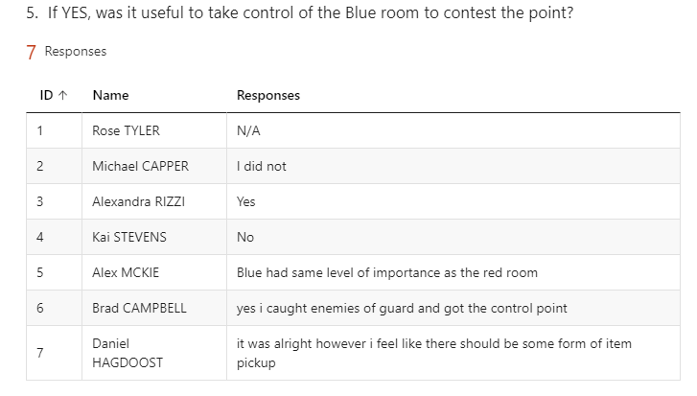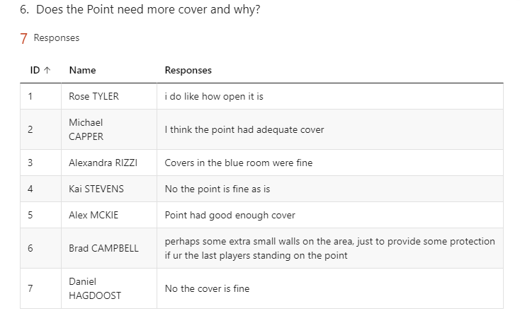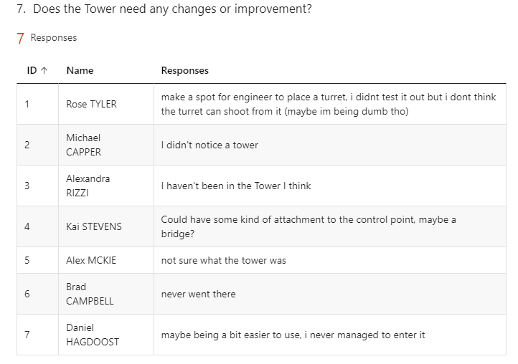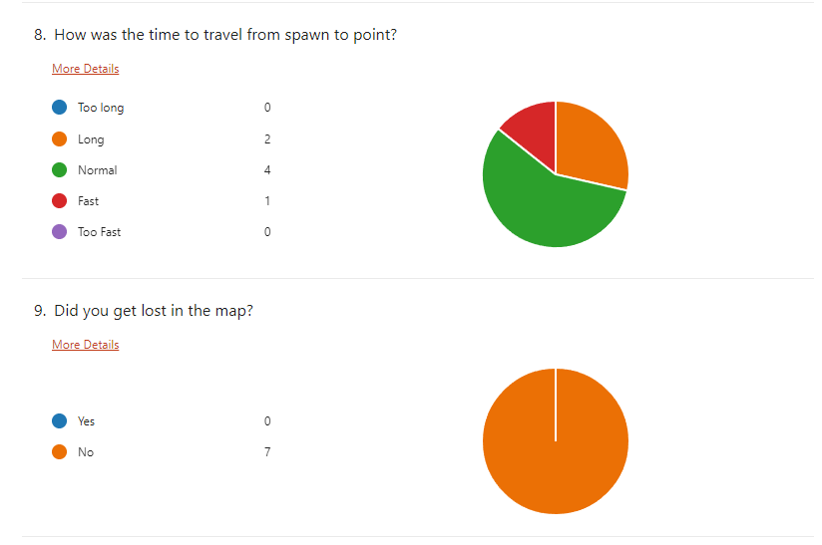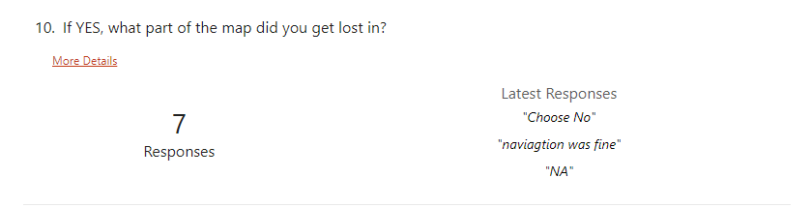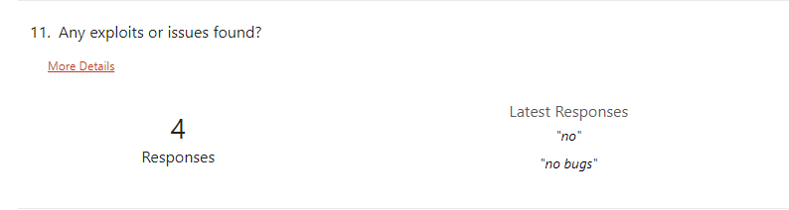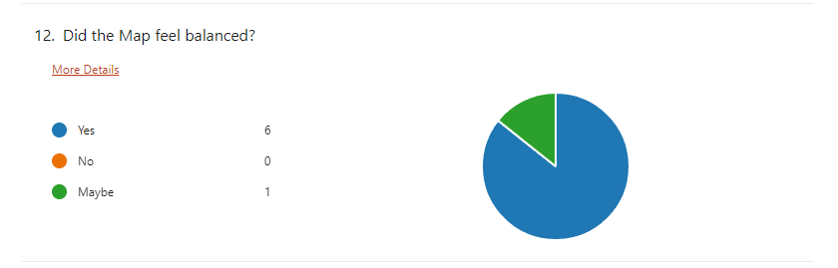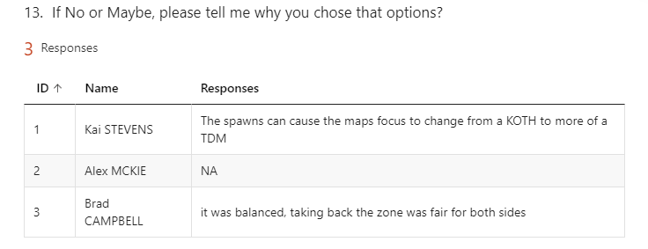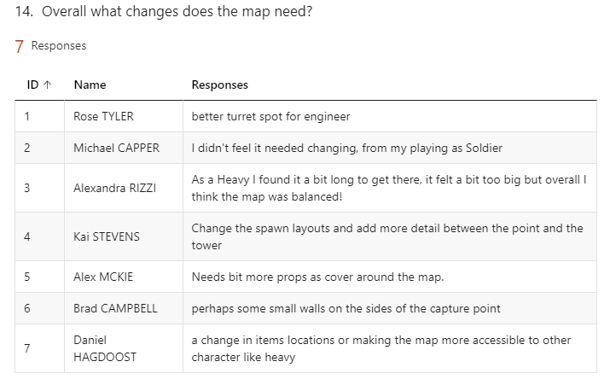

# Changelog 2

## Level Iterations

### Overview

Compared to my first play testing this one went well, and I only had to make few adjustments to the map. I think the map itself is ready to be finalized.

### Iteration #1 –Pickups Position Adjusted

#### [ Characters played ]





#### [ Feedback given ]





#### [ Feedback Overview ]

From the feedback I can see that although my pickups were placed well, they were kind of hidden from players, which resulted in players finding it hard to find the pickups. For example, Michael who played as soldier, found it hard to find pickups but once he did, he realized that they were “well placed”.

#### [ Feedback Consideration ]

I decided to adjust the pickup’s positioning to make them easy to find as well as more accessible, such as moving pickups closer to blue room and moving the pickups under tower in more open space for players to easily see.

**[ Original ]**

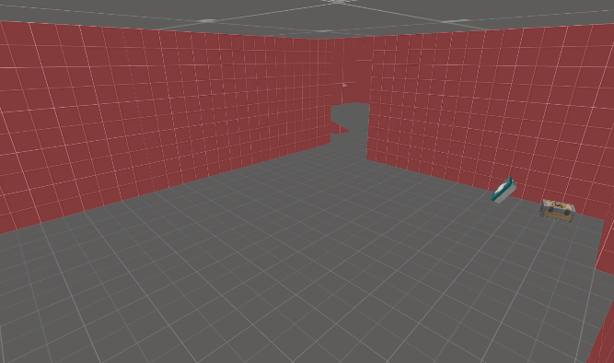 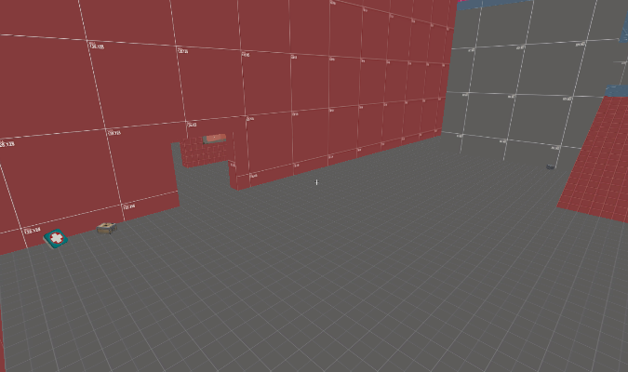

**[ Changes ]**

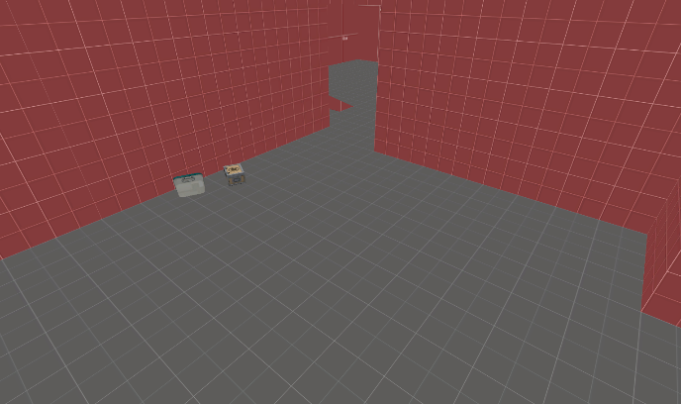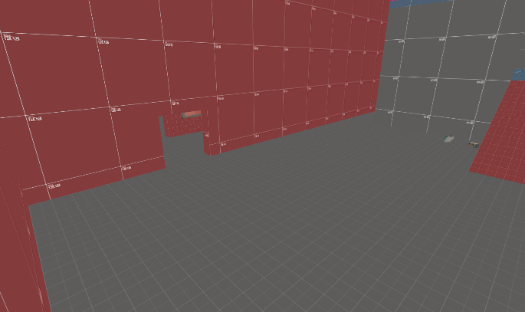

**[ Changes ] :**

* Adjusted the pickups position.
* Removed small Ammo packs.

**Inside the tower**

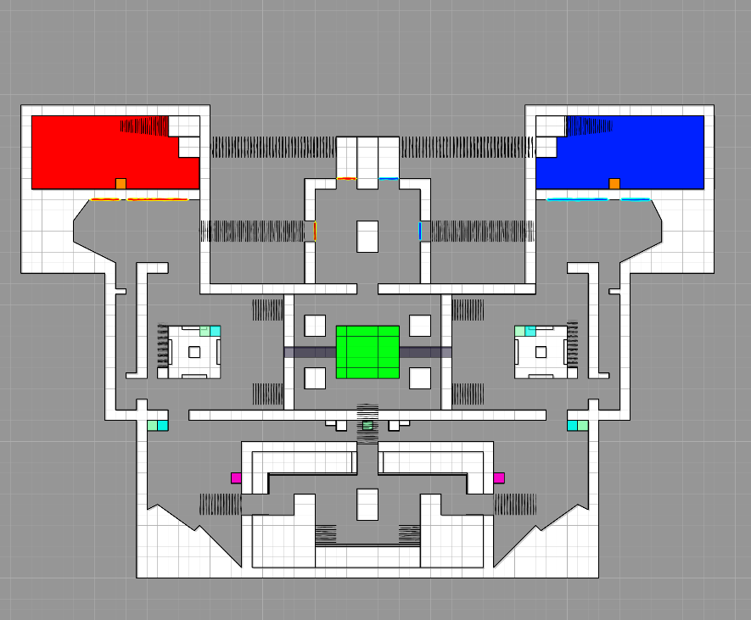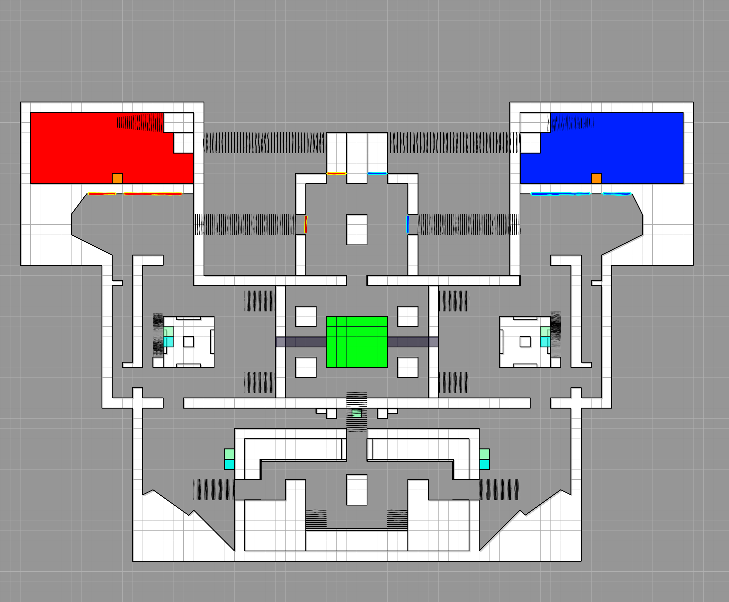

### Iteration #2 – Sentry Position Added

#### [ Characters played ]



#### [ Feedback given ]





#### [ Feedback Overview ]

The feedback suggests creating a good turret spot for the engineer, one of the recommended spots is the tower. I decided to do a little play testing with a bot to see if the turret can reach the point from the tower.

The Turret was able to reach the point but barely as it had no impact on the point, but it did make it hard for enemies to push deep into my team side as turret would stop them from overwhelming my team.

#### [ Feedback Consideration ]

However, I felt like there wasn’t enough impact, to fix that, I extended both side of the tower creating enough space for turret to be placed, and now the turret covers half of the point depending which tower or team placed the turret.

I played tested again and was concerned that this might be overpowering since the ammo pickups were right below the tower for Engineer to keep repairing. However, I took Engineer turret counter play into consideration and realized that not only can spy or scout take down the turret as well as engineer from behind, but sniper can also take them both down easily, especially the turret from across opposite tower.

**[ Original ] [ Changes ]**

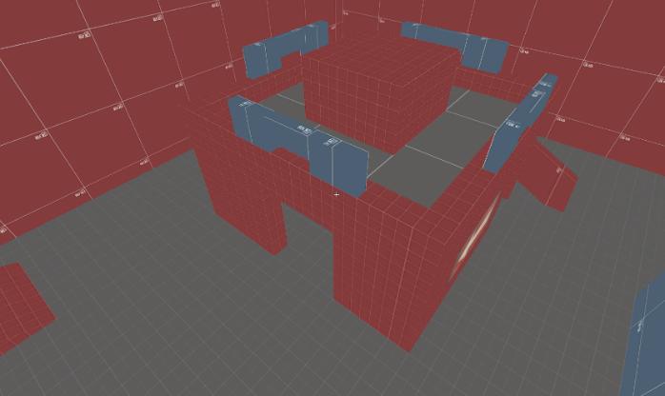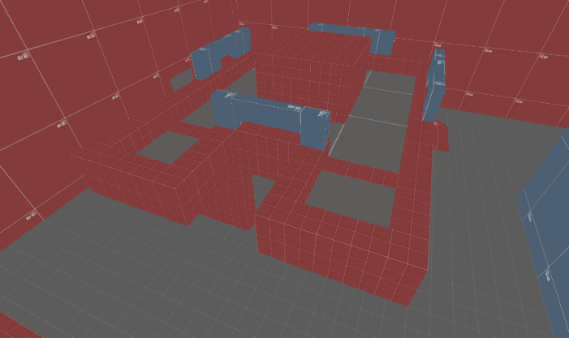

**[ Changes ] :**

* Added small space for Sentry on the Mini-Tower

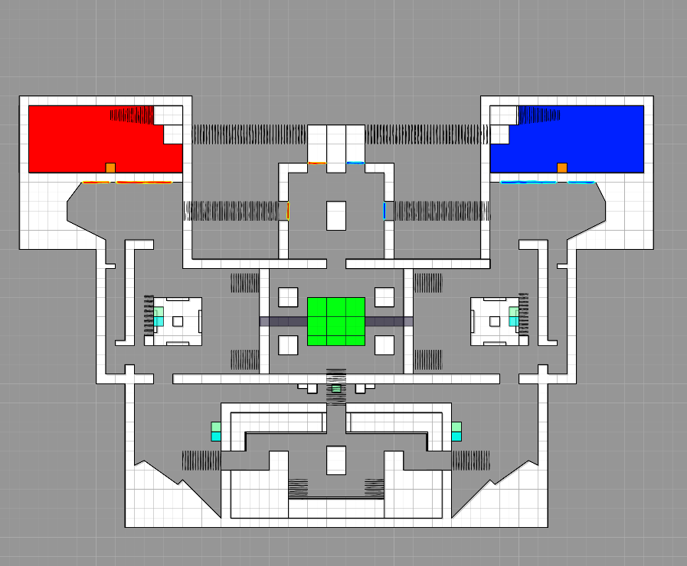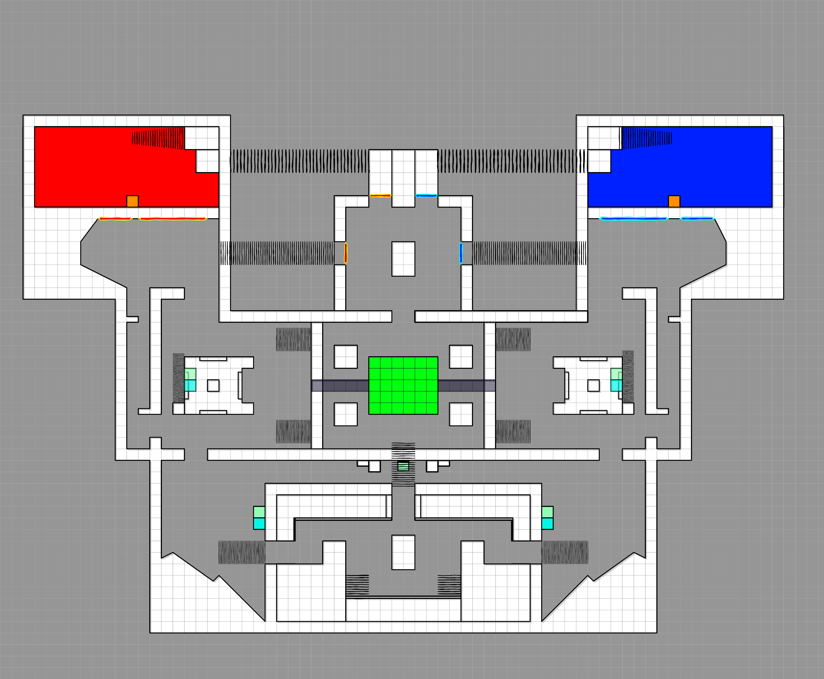

### Iteration #3 – Side Exit Cover Change

#### [ My Consideration ]

When I watched play test of my game, I saw Scout and Spy hiding in this corner and taking down players just coming out of the spawn. Although I thought it was cool, I did not like the idea of players dying when they have just come out of the spawn.

So, I decided to change the cover to see through glass so players can see someone hiding behind it. Of course, the flankers can also see players coming towards them. This should at least give players coming from spawn a fighting chance without getting surprised.

**[ Original ] [ Changes ]**

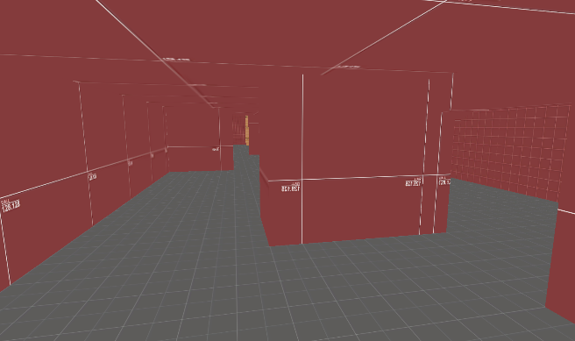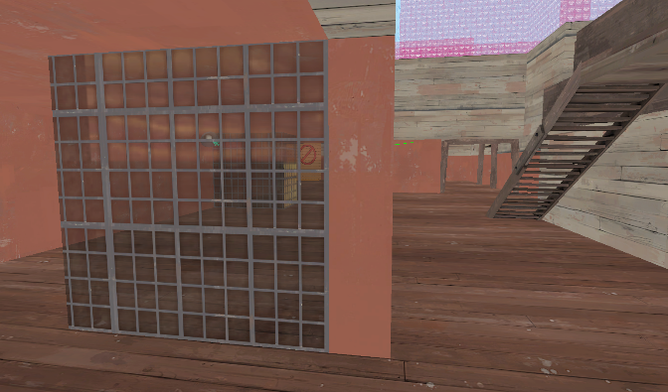

## Erroneous data

### Data # 1

#### [ Characters played ]



#### [ Feedback given ]



#### [ Feedback Review ]

The item pickups were available, in fact there were small ammo pack right next to blue room and medium health pack as well. Although this feedback could be refereeing to player having hard time finding the pickups. If so then the adjustment has already been made, which should make it easier for players to find them. (Playtest 2 - Iteration # 1)

### Data # 2

#### [ Characters played ]



#### [ Feedback given ]



#### [ Feedback Review ]

If you are the last person alive, you are expected to get overwhelmed by the enemy team, especially if they are utilizing the rooms.

The other feedback also suggests that the point is fine and does not require any cover, three of them being players that also played Heavy.

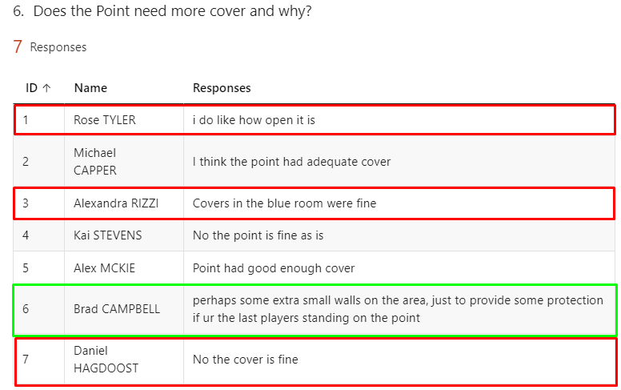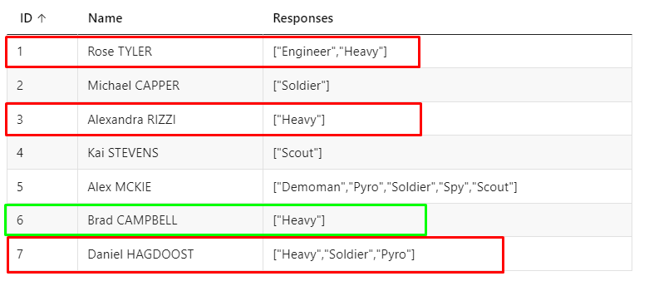

### Data # 3

#### [Characters played]



#### [ Feedback given ]



#### [ Feedback Review ]

This is not a bad idea; however, the Mini-Tower is already too close to the point and can get spammed easily, creating a bridge will make it even harder for Sniper to play the game. Addition to that, this feedback was given by Scout player, which seems silly as Scout is fast and can easily get to the tower by taking the quick flank routes.

### Data # 4

#### [ Characters played ]



#### [ Feedback given ]



#### [ Feedback Review ]

I find this information to be false, as I tested how long it takes for Heavy to travel to point using main route from other official TF2 maps and on average it takes about 15 -18 seconds. Meanwhile taking the main route from the spawn in my map takes around 12 – 14 seconds as Heavy. Which shows that it is faster and not slower.

However, the lack of detail on the map could have made it feel as if it takes long to travel to the point. This will be taken into consideration when I am applying texture and adding meshes detail to the map.

Looking at the responses I can see that majority of the players found it normal.

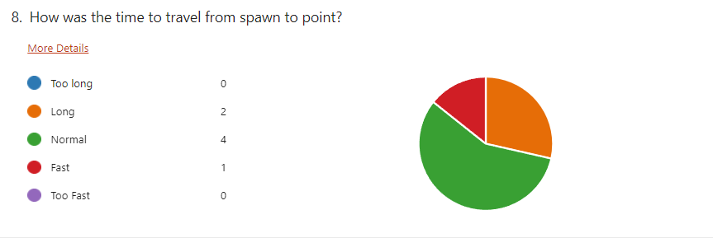

## Zoning Table 2

### Keys – Areas Characters would use the most.

**Would rather not go to**

**Go to Often**

**Go to Sometimes**

#### [ Expectation ]

|  |  |  |  |  |  |  |
| --- | --- | --- | --- | --- | --- | --- |
| **Expectation** | **Red Room** | **Blue Room** | **Tower** | **Enemy Tower** | **Point** | **Flank Routes** |
| **Scout** |  |  |  |  |  |  |
| **Spy** |  |  |  |  |  |  |
| **Soldier** |  |  |  |  |  |  |
| **Demoman** |  |  |  |  |  |  |
| **Pyro** |  |  |  |  |  |  |
| **Heavy** |  |  |  |  |  |  |
| **Medic** |  |  |  |  |  |  |
| **Sniper** |  |  |  |  |  |  |
| **Engineer** |  |  |  |  |  |  |

#### [ Actual Result ]

|  |  |  |  |  |  |  |
| --- | --- | --- | --- | --- | --- | --- |
| **Expectation** | **Red Room** | **Blue Room** | **Tower** | **Enemy Tower** | **Point** | **Flank Routes** |
| **Scout** |  |  |  |  |  |  |
| **Spy** |  |  |  |  |  |  |
| **Soldier** |  |  |  |  |  |  |
| **Demoman** |  |  |  |  |  |  |
| **Pyro** |  |  |  |  |  |  |
| **Heavy** |  |  |  |  |  |  |
| **Medic** |  |  |  |  |  |  |
| **Sniper** |  |  |  |  |  |  |
| **Engineer** |  |  |  |  |  |  |

#### [ Result Overview ]

Overall, I am satisfied with the result as almost all the characters used the map the way I expected them to. This time the rooms were being used and it seems like the iteration I made worked.

##### **[ Evidence ]**

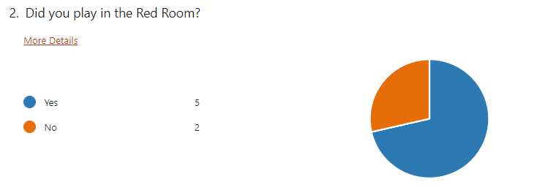

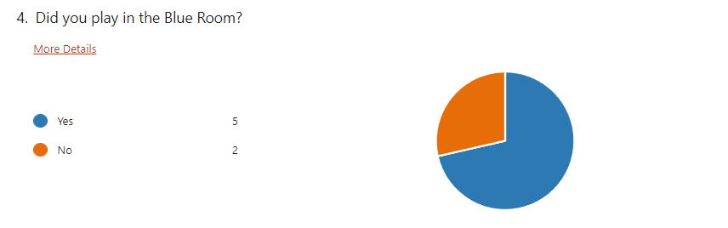

The only character I had to make changes for mainly was the Engineer as he did not seem to have good spot to place Sentry, I was expecting the Tower to be used but it seems like Sentry on the Tower did not have much impact.

##### **[ Evidence ]**

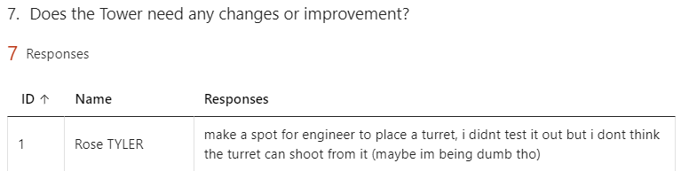

# Comparing Playtests Result

## Were my Iterations a success?

After my first play test I made a lot of changes in the level according to the feedback given and the changes I thought my map needed. During Second play test I saw that all my changes worked well as players did not complain about the same things again. I also asked questions to confirm it.

### Example #1

Before blue and red room were not really being used in the game, this was a problem and I made couple of changes to fix it.





After the changes the only players that did not make use of red and blue room were the Heavy players, which made sense as they prioritized the point first.

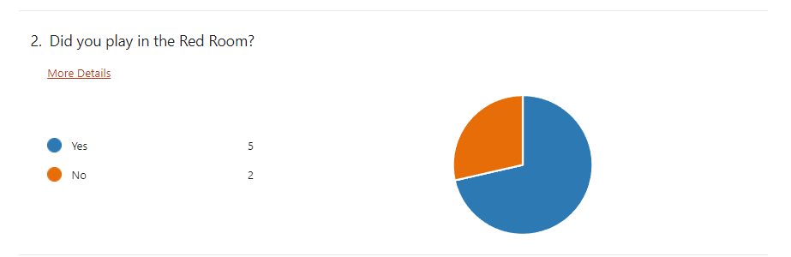

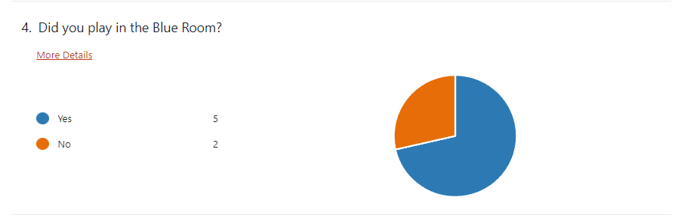

### Example #2

During Playtest one players were getting lost and confused about where the point was.





However, during playtest two I asked if anyone got lost in the map, the result was no one did.

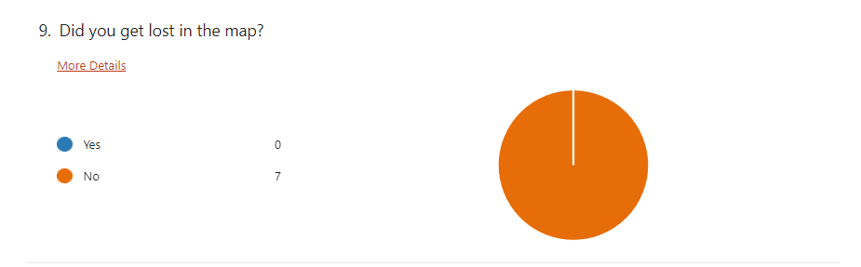

### Example #3

Before I asked if the map felt balanced and many players felt like it was not well balanced.

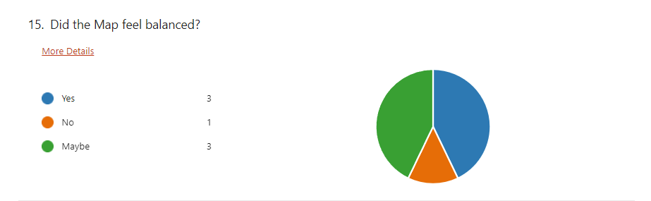

However, after my iteration almost everyone thought that the map was well balanced for both side during attack and defense.

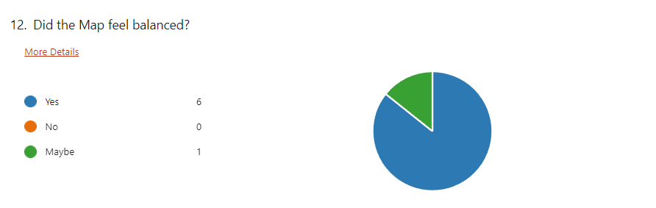

# Overall Changes (Gif)



